

**BENGAL INSTITUTE OF BUSINESS STUDIES**

Proof of Concept

On

**(DATA SCIENCE)**

**Topic:** GDP Per Capita Analysis

**Submitted by**

**Name:** Abhishek Sharma

**Program Name:** MBA (Business Analytics & Data Science)

Under the Guidance of

**Mr Kuldeep Gupta (IBM)**

**Programing for Data science**

Date - 20.09.2021 to 9.12.2021

**DECLARATION**

I hereby declare that the information given in this application is true and correct to the best of my knowledge and belief.

I hereby undertake that the project undertaken by me is the genuine work of mine.

Name :- **ABHISHEK SHARMA**

Place: - Kolkata

Date – 9/12/2021

## ACKNOWLEDGEMENT

I would like to express my sincere gratitude to several individuals and organizations for supporting me throughout my post-Graduate study. First, I wish to express my sincere gratitude to my supervisor, Professor (Kuldeep Gupta), for his enthusiasm, patience, insightful comments, helpful information, practical advice and unceasing ideas that have helped me tremendously at all times in my research and writing of this thesis.  His immense knowledge, profound experience and professional expertise in Data Quality Control has enabled me to complete this research successfully. Without his support and guidance, this project would not have been possible. I could not have imagined having a better supervisor in my study.

## Table of Contents

|  |  |
| --- | --- |
| SL.NO | Topics |
| 1. | Introduction |
|  | 1.1 Purpose |
|  | 1.2 Project Scope |
|  | 1.3 References |
|  | 1.4 About Datasets |
|  | 1.5 Details of Data Set |
|  | 1.6 Attribute Information |
| 2. | Tools and Working Essential |
|  | 2.1 Tools used in this Dataset |
|  | 2.2 Queries and objectives |
| 3. | Workings |
|  | 3.1 Coding |
|  | 3.2 Findings and visualisation |
| 4. | Conclusion |

**1. Introduction**

**Data science**

Data science is a multidisciplinary approach to extracting actionable insights from the large and ever-increasing volumes of data collected and created by today’s organizations. Data science encompasses preparing data for analysis and processing, performing advanced data analysis, and presenting the results to reveal patterns and enable stakeholders to draw informed conclusions.

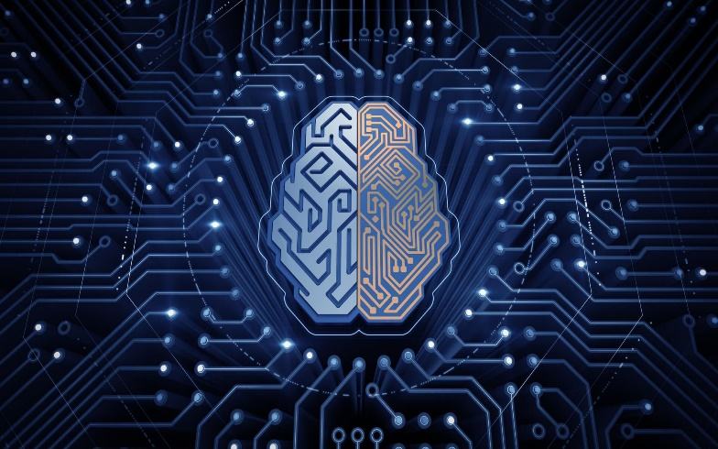

## Data preparation can involve cleansing, aggregating, and manipulating it to be ready for specific types of processing. Analysis requires the development and use of algorithms, analytics and AI models. It’s driven by software that combs through data to find patterns within to transform these patterns into predictions that support business decision-making. The accuracy of these predictions must be validated through scientifically designed tests and experiments. And the results should be shared through the skill full use of data visualization tools that make it possible for anyone to see the patterns and understand trends.

As a result, data scientists (as data science practitioners are called) require computer science and pure science skills beyond those of a typical data analyst. A data scientist must be able to do the following:

* Apply mathematics, statistics, and the scientific method
* Use a wide range of tools and techniques for evaluating and preparing data—everything from SQL to data mining to data integration methods
* Extract insights from data using predictive analytics and artificial intelligence (AI), including machine learning and [deep learning](https://www.ibm.com/cloud/learn/deep-learning) models
* Write applications that automate data processing and calculations
* Tell—and illustrate—stories that clearly convey the meaning of results to decision-makers and stakeholders at every level of technical knowledge and understanding
* Explain how these results can be used to solve business problems.

So here an important question arises, what is Data?

Data refers to distinct pieces of information, usually formatted and stored in a way that is concordant with a specific purpose. Data can exist in various forms: as numbers or text recorded on paper, as bits or bytes stored in electronic memory, or as facts living in a person’s mind. Since the advent of computer science in the mid-1900s, however, data most commonly refers to information that is transmitted or stored electronically.

All data can be categorized as machine-readable, human-readable, or both. Human-readable data utilizes natural language formats (such as a text file containing [ASCII codes](https://www.webopedia.com/definitions/ascii/) or [PDF](https://www.webopedia.com/definitions/pdf-2/) document), whereas machine-readable data uses formally structured computer languages (Parquet, Avro, etc.) to be read by computer systems or software. Some data is readable by both machines and humans, as in the case of [CSV](https://www.webopedia.com/definitions/csv/), [HTML](https://www.webopedia.com/definitions/html/), or [JSON](https://www.webopedia.com/definitions/json/).

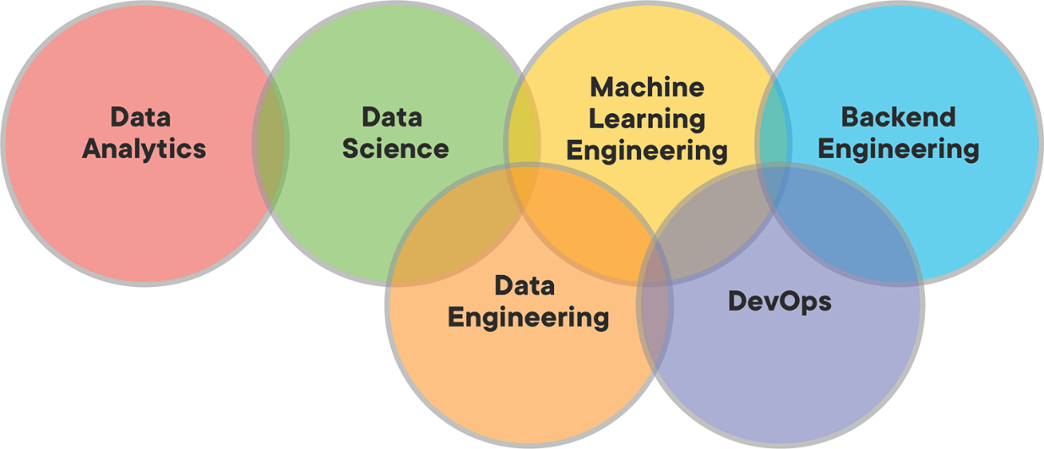

## DATA PHRASES IN TECHNOLOGY

Data has become the forefront of many mainstream conversations about technology. New innovations constantly draw commentary on data, how we use and analyze it, and broader implications for those effects. As a result, the popular IT vernacular has come to include a number of phrases new and old:

* [Big data](https://www.webopedia.com/definitions/big-data/): A massive volume of structured and unstructured data that is too large to process using traditional database and software technologies.
* [Big data analytics](https://www.webopedia.com/definitions/big-data-analytics/): The process of collecting, organizing, and synthesizing large sets of data to discover patterns or other useful information.
* [Data center](https://www.webopedia.com/definitions/data-center/): Physical or virtual infrastructure used by enterprises to house computer, storage, and networking systems and components for the company’s IT needs.
* [Data integrity](https://www.webopedia.com/definitions/data-integrity/): The validity of data, which can be compromised in a number of ways including human error or transfer errors.
* [Data miner](https://www.webopedia.com/definitions/data-miner/): A software application that monitors and/or analyzes the activities of a computer, and subsequently its user, to collect information.
* [Data mining](https://www.webopedia.com/definitions/data-mining/): A class of database applications that look for hidden patterns in a group of data that can be used to predict/anticipate future behaviour.
* [Data warehouse](https://www.webopedia.com/definitions/data-warehouse/): A data management system that uses data from multiple sources to promote business intelligence.
* [Database](https://www.webopedia.com/definitions/database/): A collection of data points organized in a way that is easily maneuvered by a computer system.
* [Metadata](https://www.webopedia.com/definitions/metadata/): Summary information about a data set.
* [Raw data](https://www.webopedia.com/definitions/raw-data/): Information that has been collected but not formatted or analyzed.
* [Structured data](https://www.webopedia.com/definitions/structured-data/): Any data that resides in a fixed field within a record or file, including data contained in relational databases and spreadsheets.
* [Unstructured data](https://www.webopedia.com/definitions/unstructured-data/): Information that does not reside in a traditional column-row database like structured data.

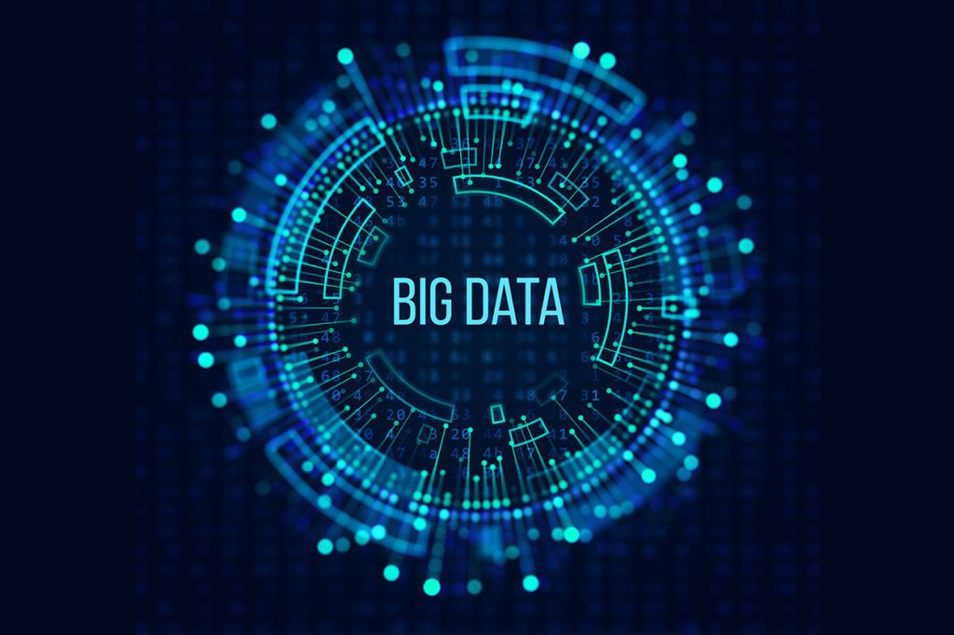

**Tools required in data science**

### SAS

### Apache Spark

### Big ML

### MATLAB

### Excel

### Tableau

### Jupyter

### Scikit-learn

### TensorFlow

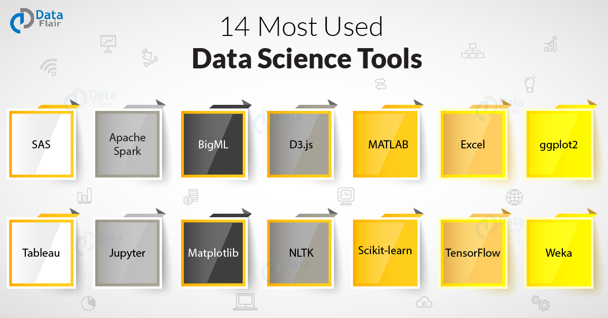

### **Expertise for Data science**

### Data science involves high coding expertise. And like with many technical fields, skill demand and expectations are always evolving. Data science requires expertise in programming languages.

**What is a programming language?**

Programming languages, to put it simply, are the languages used to write lines of code that make up a software program. These lines of code are digital instructions, commands, and other syntaxes that are translated into digital output. There are 5 main types of programming languages:

1. Procedural Programming Languages
2. Functional Programming Languages
3. Object-Oriented Programming Languages
4. Scripting Programming Languages
5. Logic Programming

**Important programming languages for Data science**

#### Python

#### JavaScript

#### Java

#### R

#### C/C++

#### SQL

#### Scala

#### Julia

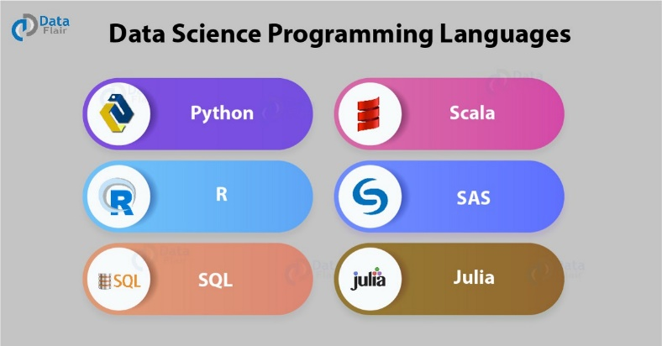

* 1. **Purpose**

Per capita GDP is a global measure for gauging the prosperity of nations and is used by economists, along with GDP, to analyze the prosperity of a country based on its economic growth.

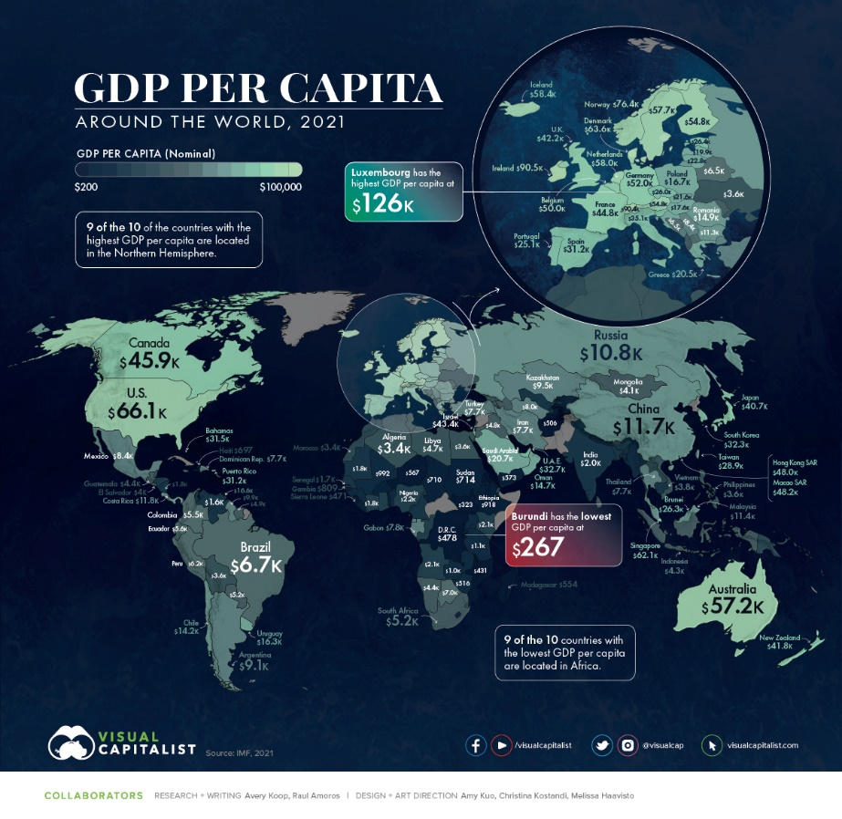

In this Data Science Project, I am investigating the dataset “Countries of the World”. I will be focusing on the factors affecting a country’s GDP per capita and try to make a model using the data of 227 countries from the dataset. I will also briefly discuss the total GDP.

* 1. **Project scope**
* It can be used to anticipate the earning of individuals from different countries.
* This analysis will be helpful for Multinational companies to strategize their plans according to the level of spending of different individuals.
* It will give a brief idea about economic growth and stability of countries.
* We can also understand the close correlation of GDP per capita with the trend in living standards over time.
  1. **References**

[**https://www.kaggle.com**](https://www.kaggle.com)

[**https://github.com/**](https://github.com/)

[**https://data.oecd.org/gdp/gross-domestic-product-gdp.htm**](https://data.oecd.org/gdp/gross-domestic-product-gdp.htm)

[**https://www.imf.org/en/Data**](https://www.imf.org/en/Data)

* 1. **About Dataset**

Name of this dataset is “countries of the world”, it gives a brief geographical, economical and social information of total 227 countries.

This dataset is helpful in finding trends, living standards and hidden patterns which will be further used in achieving our goals.

This is an authentic data which is provided by IMF in 2020.

**1.5 Details of Dataset**

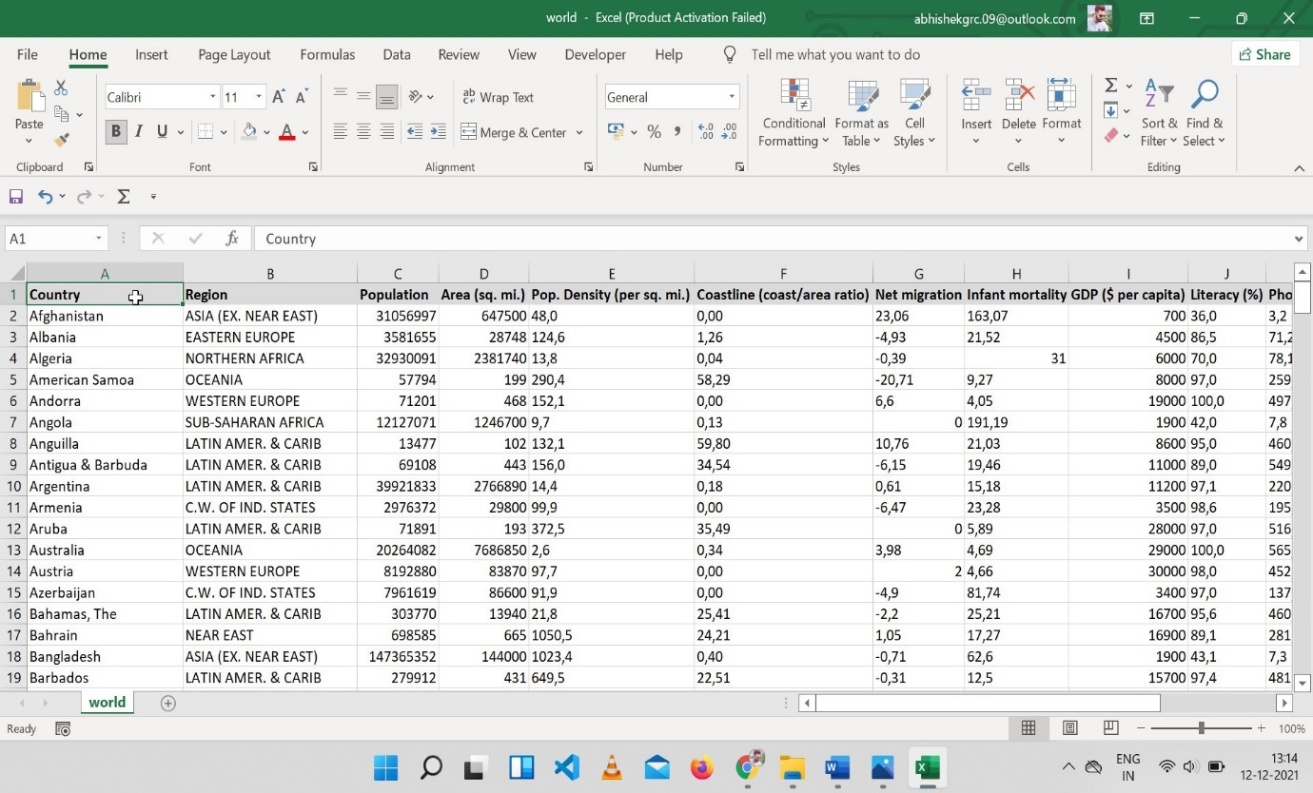

The above data is downloaded from IMF.org in the format of CSV it contains the record of 227 countries due to that it has 228 rows. This data has the 20 (Twenty) column which include Country, region, population, Area (sq. mi), Pop density (per sq. mi), coastline, net migration, infant mortality rate, GDP (per capita, $), literacy, phone(per1000),

Arable %, crops %, birth-rate, death-rate, agriculture, industry and service.

This data also includes some missing data, some empty columns which will be removed further with the help of python.

* 1. **Attribute information**

Out of 20 attributes the important attributes are: -

|  |  |
| --- | --- |
| Country | Contains list of 227 countries. |
| Population | Population size is required to calculate GDP Per capita. |
| Net migration | It reflects the employment status of that country. |
| Area | Geographical landmass of a country |
| GDP per capita $ | One of the important aspect is GDP per capita, it will be used to solve a lot of queries. |
| Arable% | Percentage of suitable land for agriculture. |
| Crops% | Crops produce in a year. |
| Agriculture | Income from agriculture sector. |
| Industry | Income from industrial sector. |
| Service | Income from service sector. |

**2. Tools and Essentials**

**2.1 Tools used for this dataset.**

* 1. Excel.
  2. Python (Jupyter) used for coding.
  3. NumPy used for performing Linear algebra.
  4. Pandas is used for data processing.
  5. Seaborn and Matplotlib is used for enhanced data visualisation.
  6. Scikit-learn (Sklearn) is used for modelling.

**2.2 Queries and Objectives.**

1) Top countries with highest per capita income $.

2) Factors affecting GDP per capita.

3) Relation between GDP per capita and birth rate.

4) Calculation of Total GDP of a country though GDP per capita and population.

5) Factors affecting Total GDP nominal.

6) Comparison between countries.

**3. workings**

In this Data Science Project, I am investigating the dataset “Countries of the World”. I will be focusing on the factors affecting a country’s GDP per capita and try to make a model using the data of 227 countries from the dataset. I will also briefly discuss the total GDP.

**Let’s start by importing the required Python libraries.**

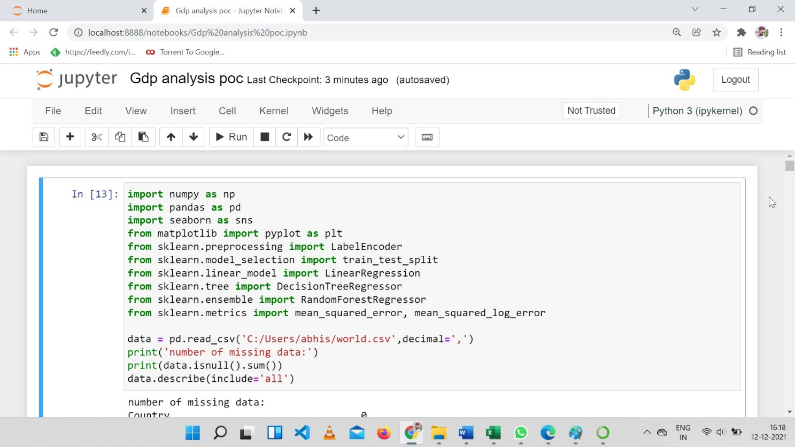

**Let’s look at the data**

**output**

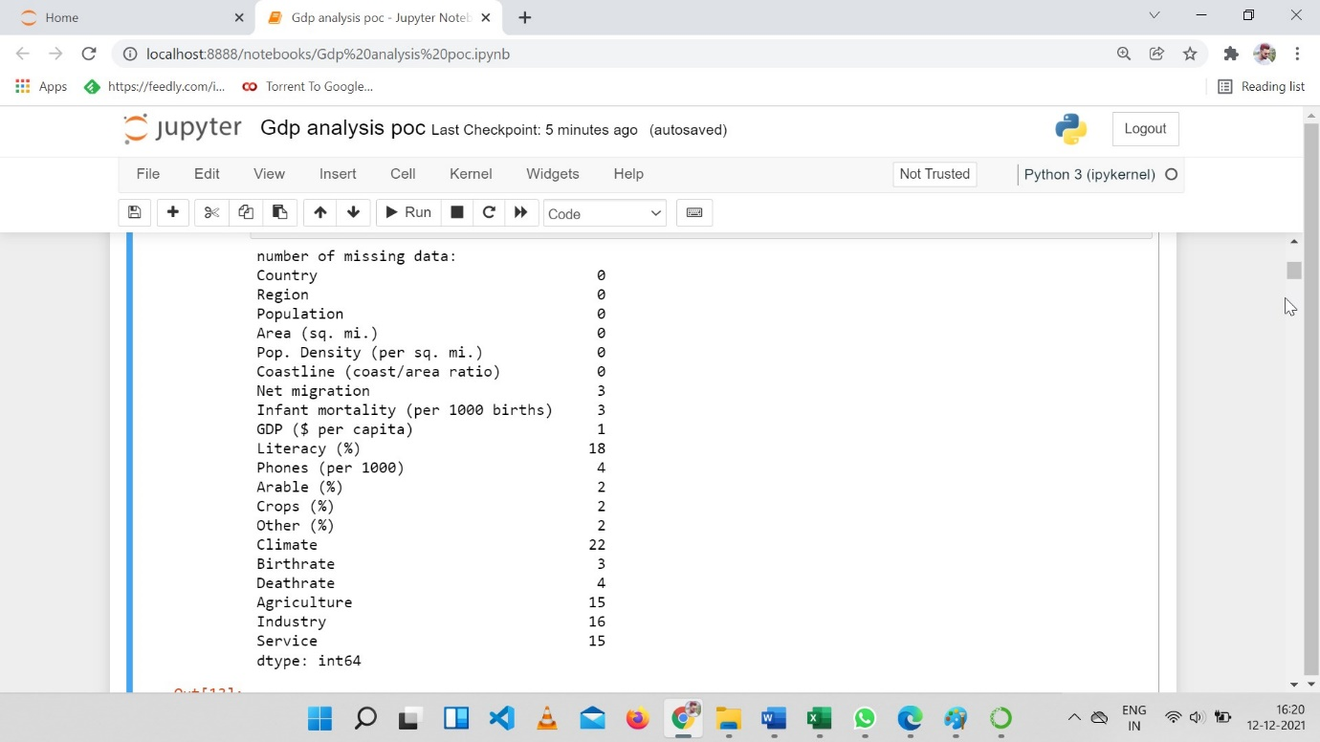

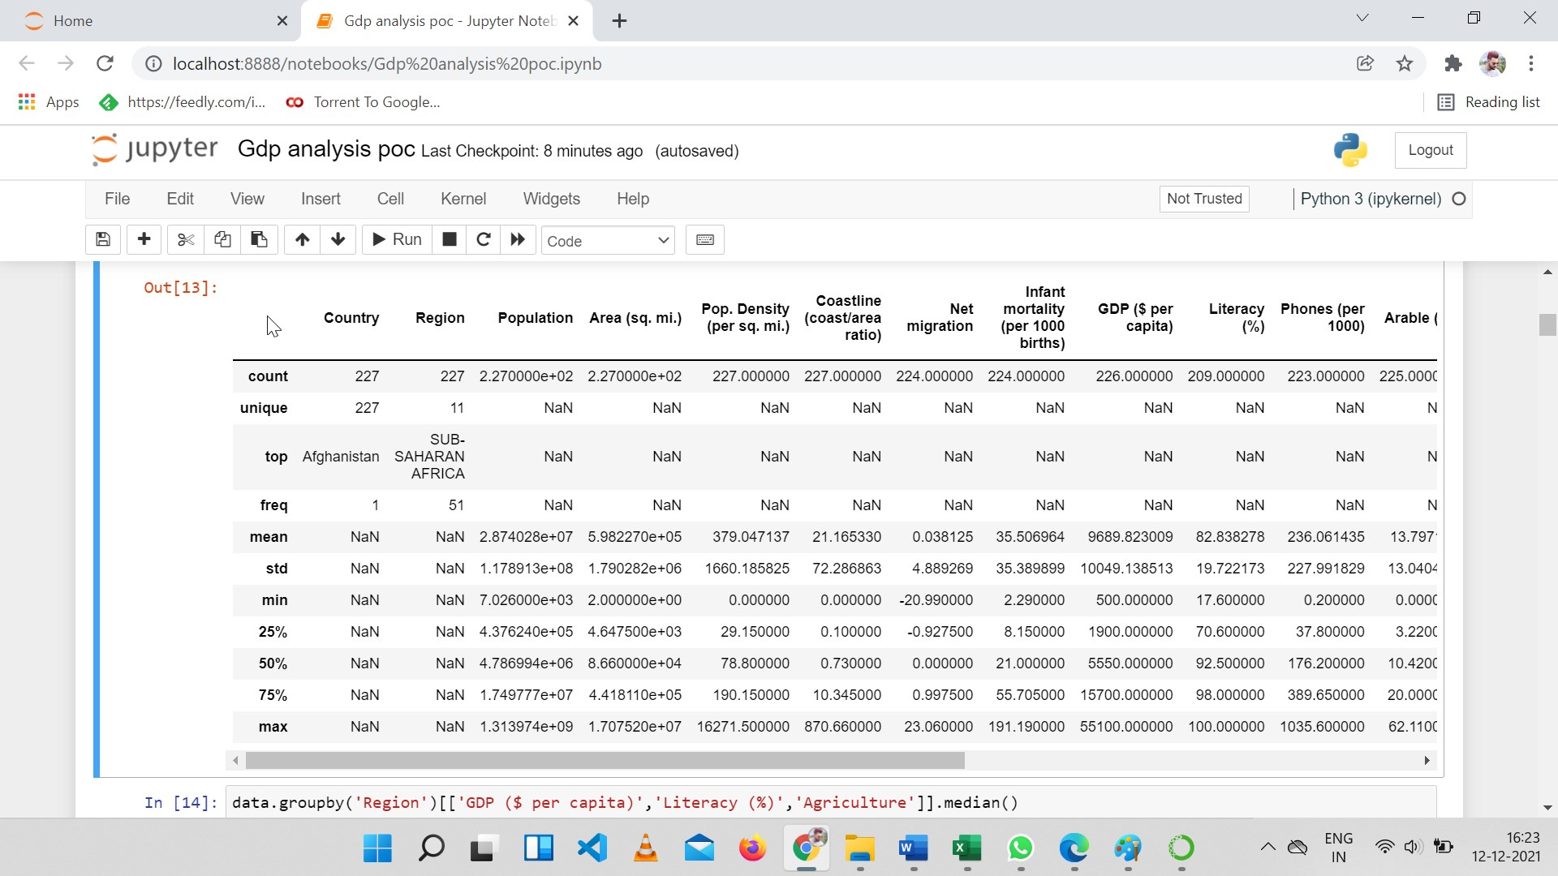

### **Data Preparation – fill in missing values**

As we can noticed that there are some missing data in the table. For simplicity, I will just fill the missing data using the median of the region that a country belongs, as countries that are close geologically are often similar in many ways. For example, let’s check the region median of ‘GDP ($ per capita)’, ‘Literacy (%)’ and ‘Agriculture’.

Note that for ‘climate’ I used the mode instead of median as it seems that ‘climate’ is a categorical feature here.

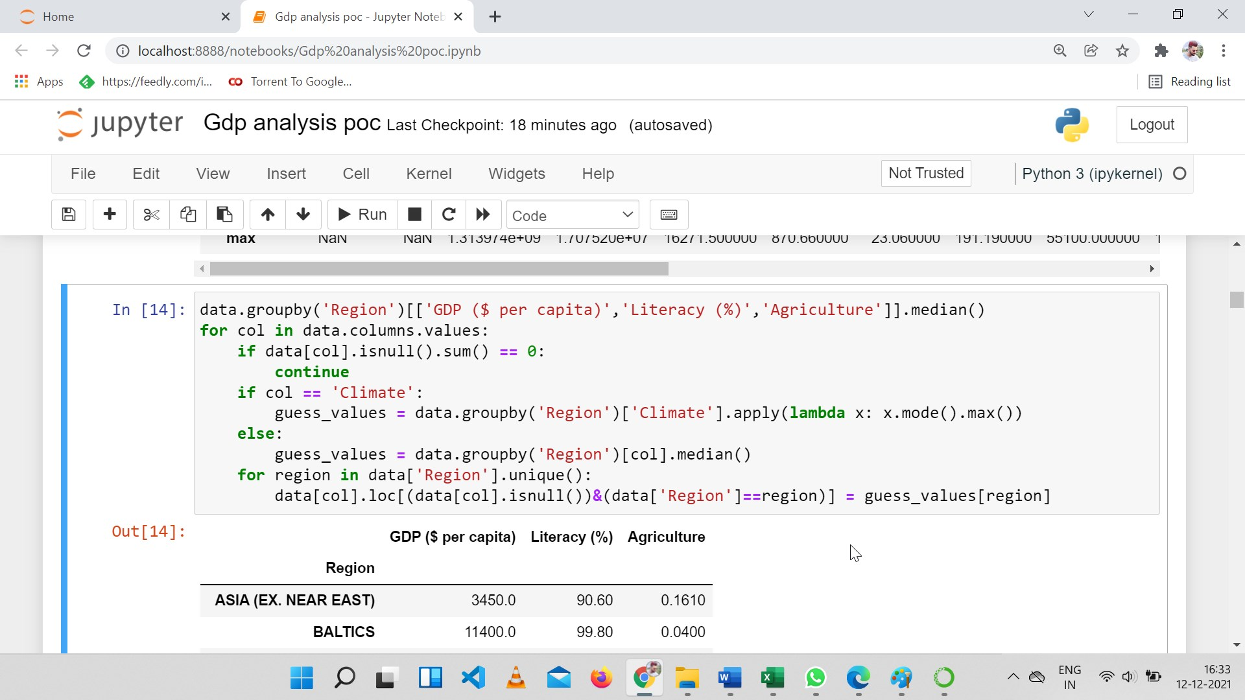

Output

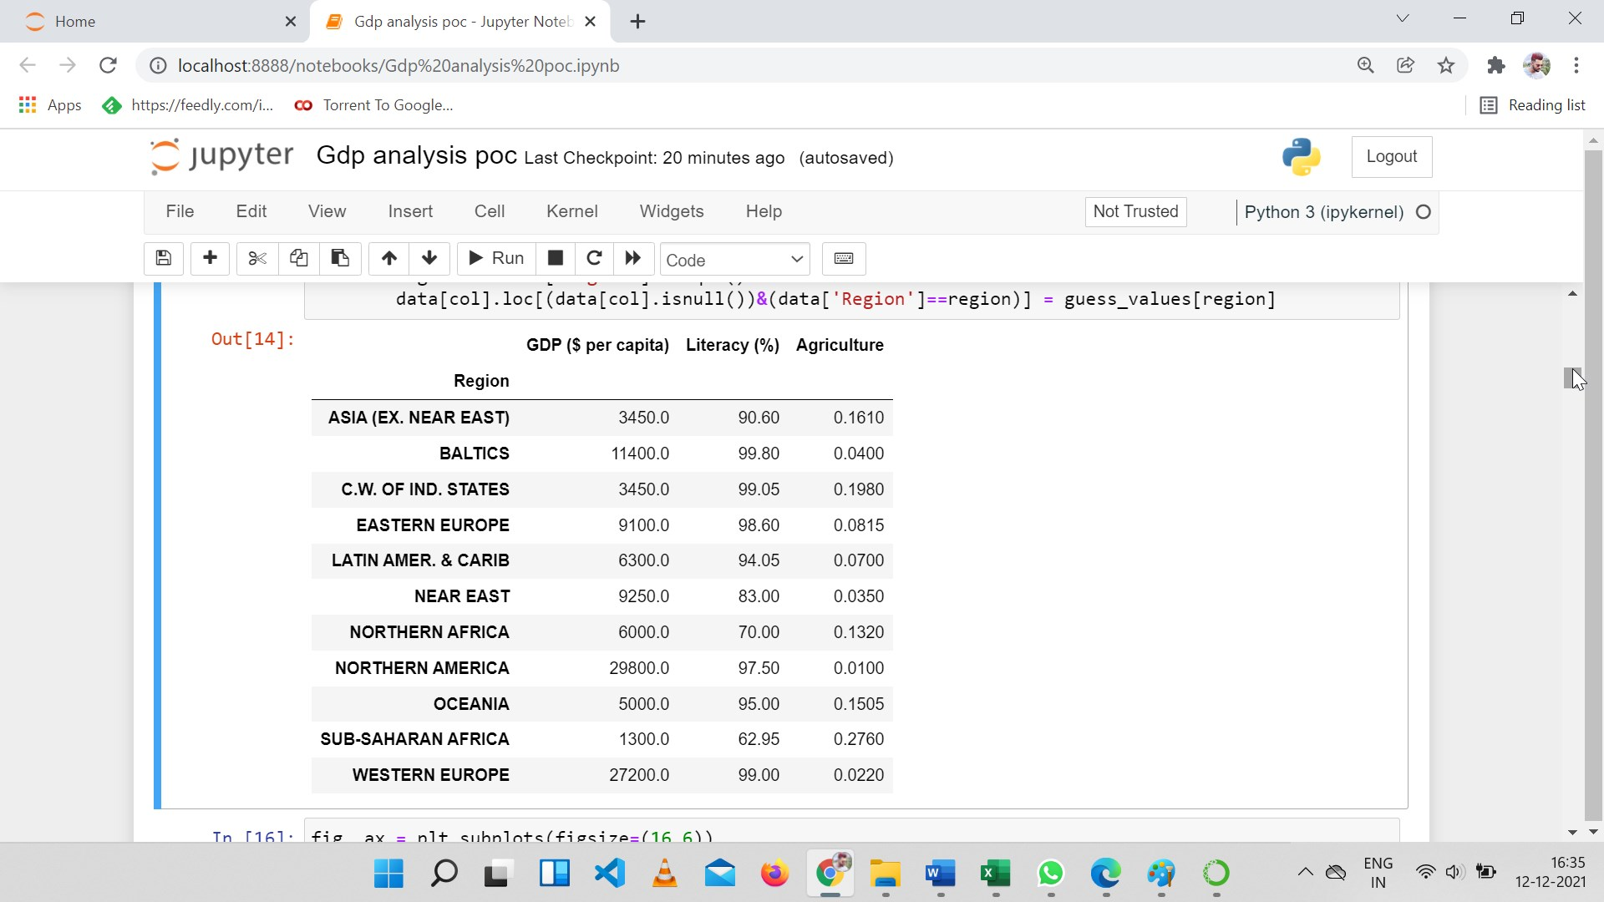

## Data Exploration

### Top Countries with highest GDP per capita

Look at the top 20 countries with highest GDP per capita. Luxembourg is quite ahead; the next 19 countries are close. German, the 20th has about 2.5 times GDP per capita of the world average.

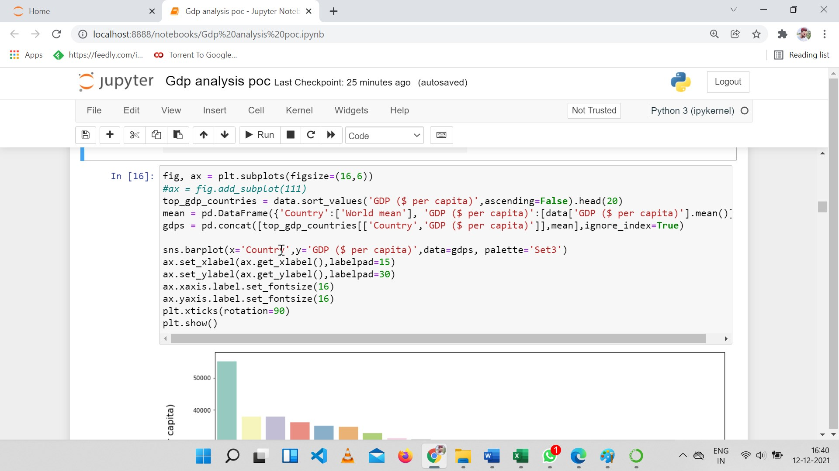

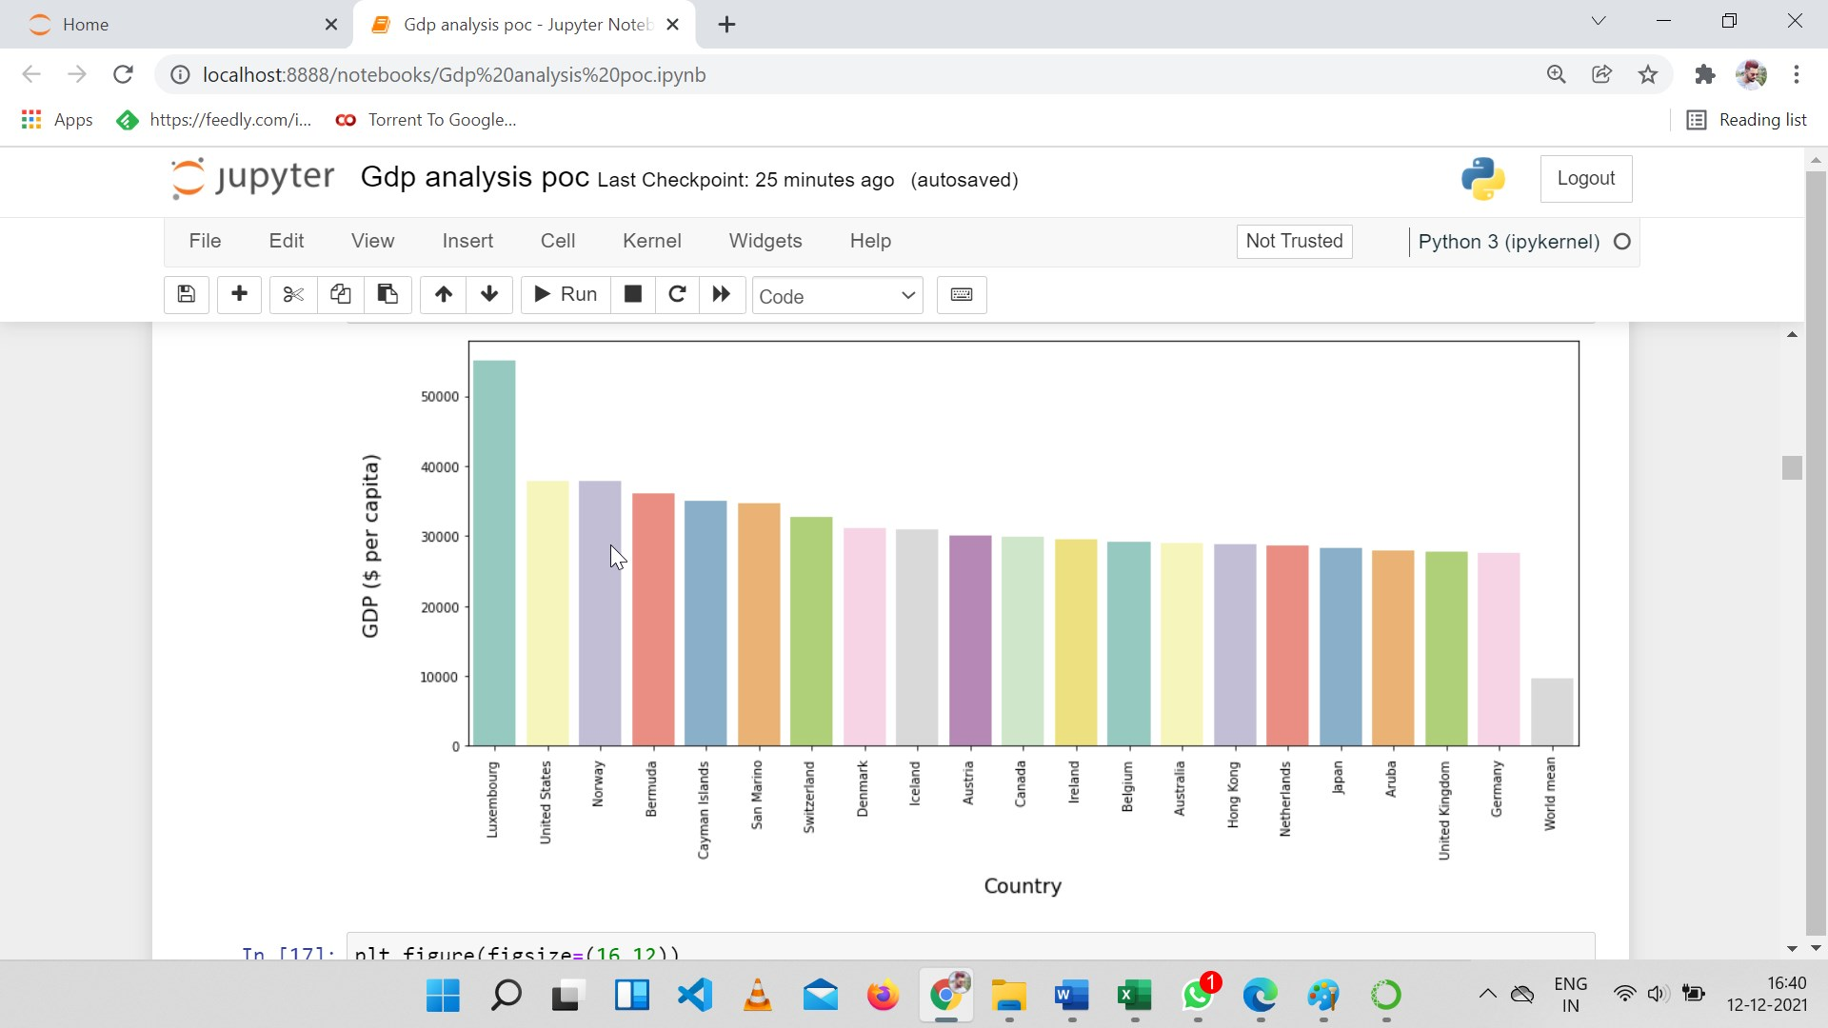

### **Correlation between Variables**

### 

**This heatmap shows the correlation between all numerical columns.**

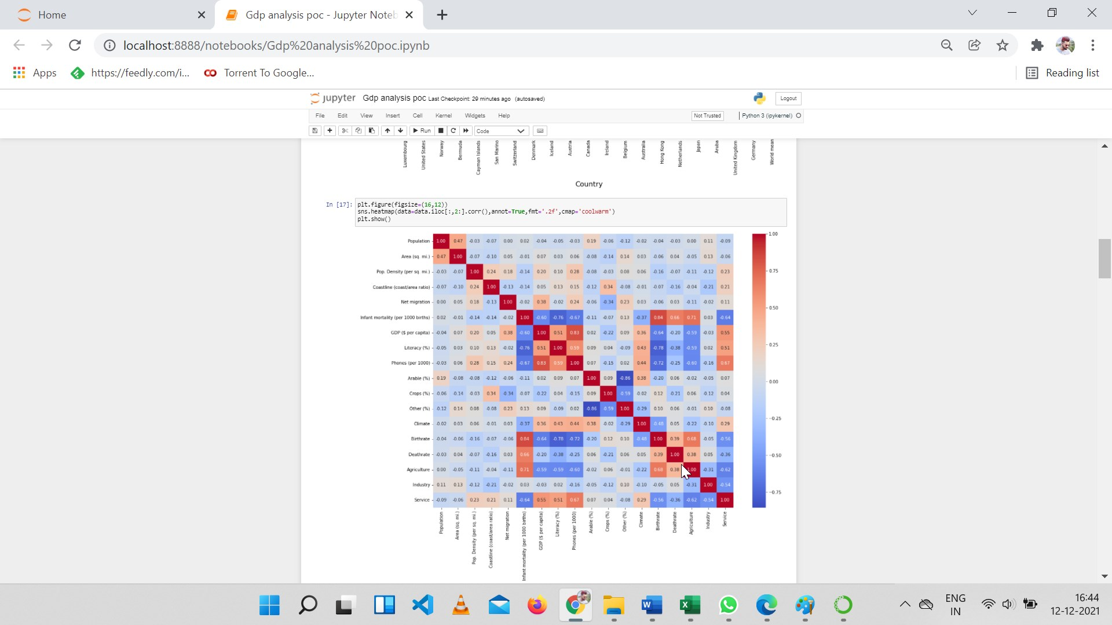

### **Top Factors affecting GDP per capita**

Let’s pick the six columns that mostly correlated to GDP per capita and make scatter plots. The results agree with our common sense. Also, I noticed there are many countries with low average GDP and few with high average GDP a pyramid structure.

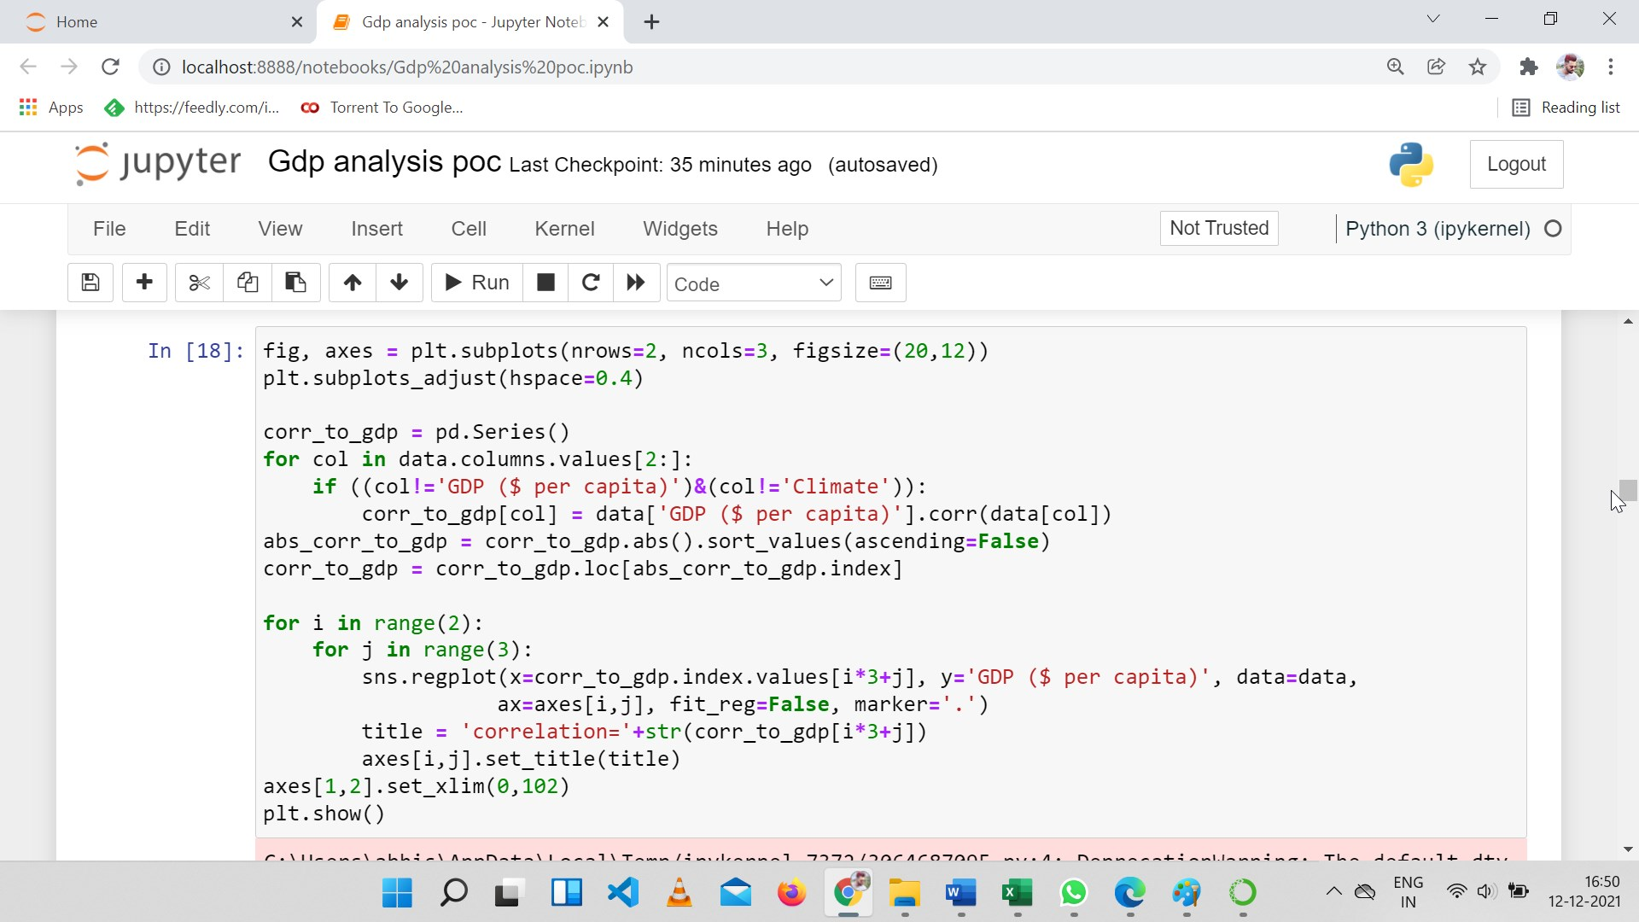

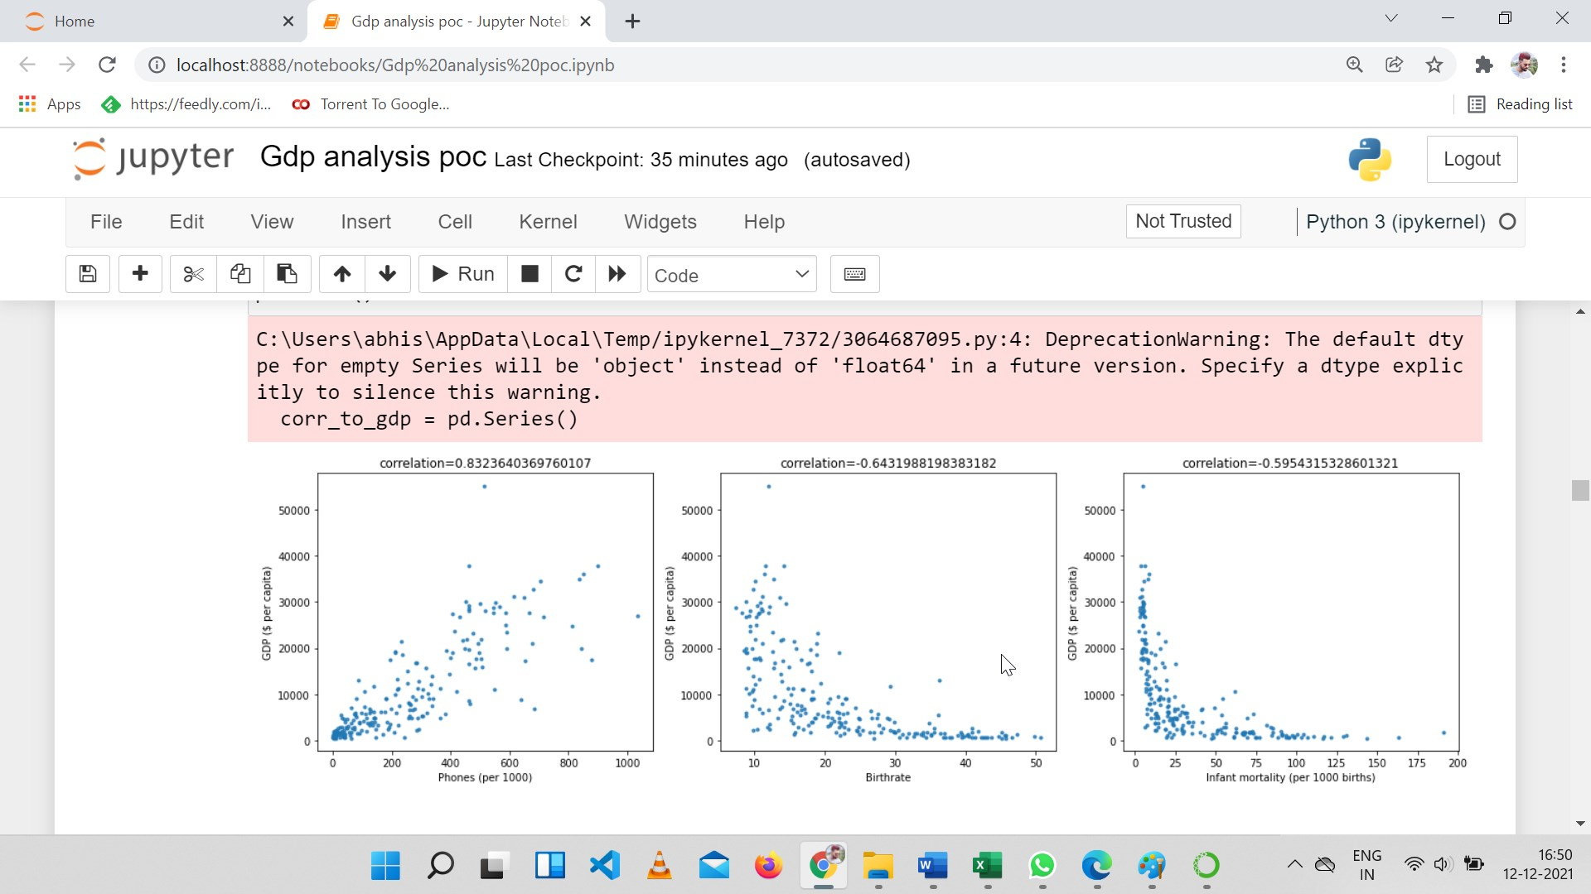

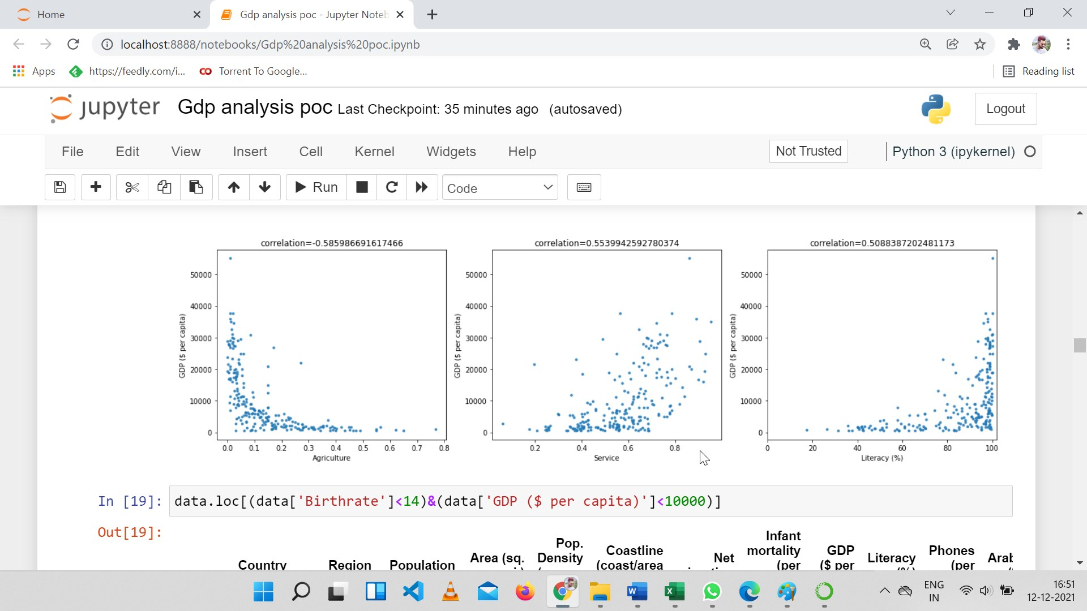

### **Countries with low Birthrate and low GDP per capita**

Some features, like phones, are related to the average GDP more linearly, while others are not. For example, High birthrate usually means low GDP per capita, but average GDP in low birthrate countries can vary a lot.

Let’s look at the countries with low birthrate (<14%) and low GDP per capita (<10000 $). They also have hight literacy, like other high average GDP countries. But we hope their other features can help distinguish them from those with low birthrate but high average GDPs, like service are not quite an important portion in their economy, not a lot phone procession, some have negative net migration, and many of them are from eastern Europe or C.W. of IND. STATES, so the ‘region’ feature may also be useful.



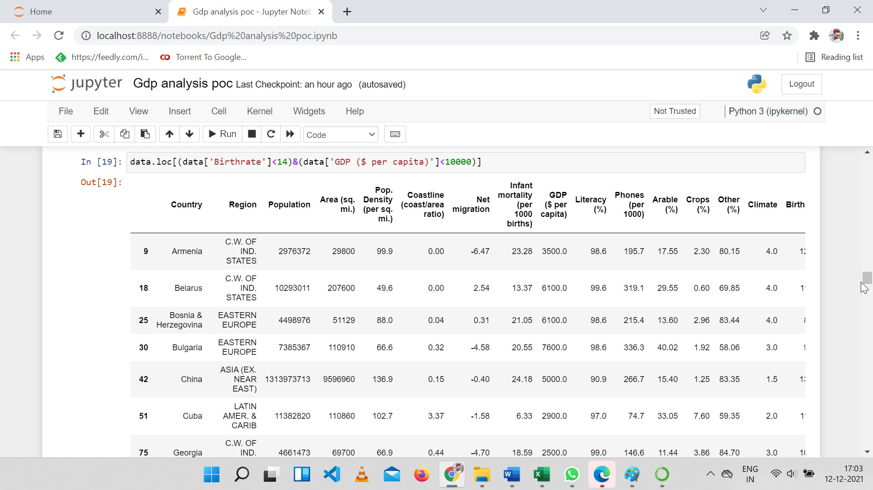

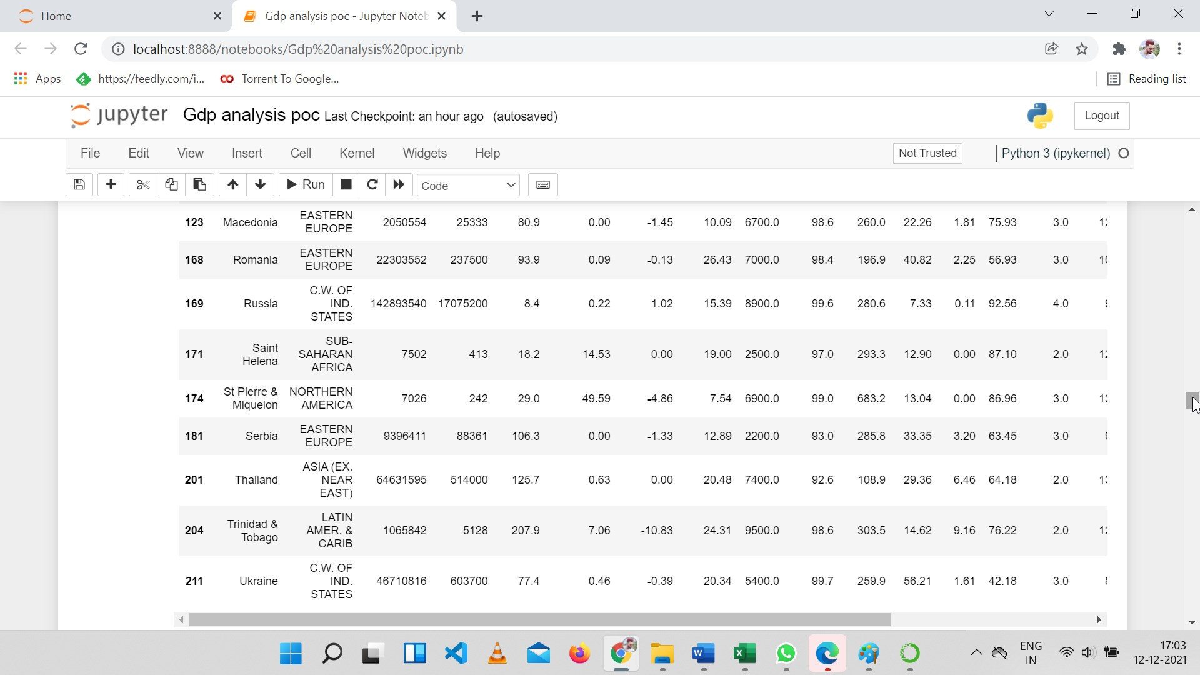

## Modelling

### Training and Testing

First label encodes the categorical features ‘Region’ and ‘Climate’, and I will just use all features given in the data set without further feature engineering.

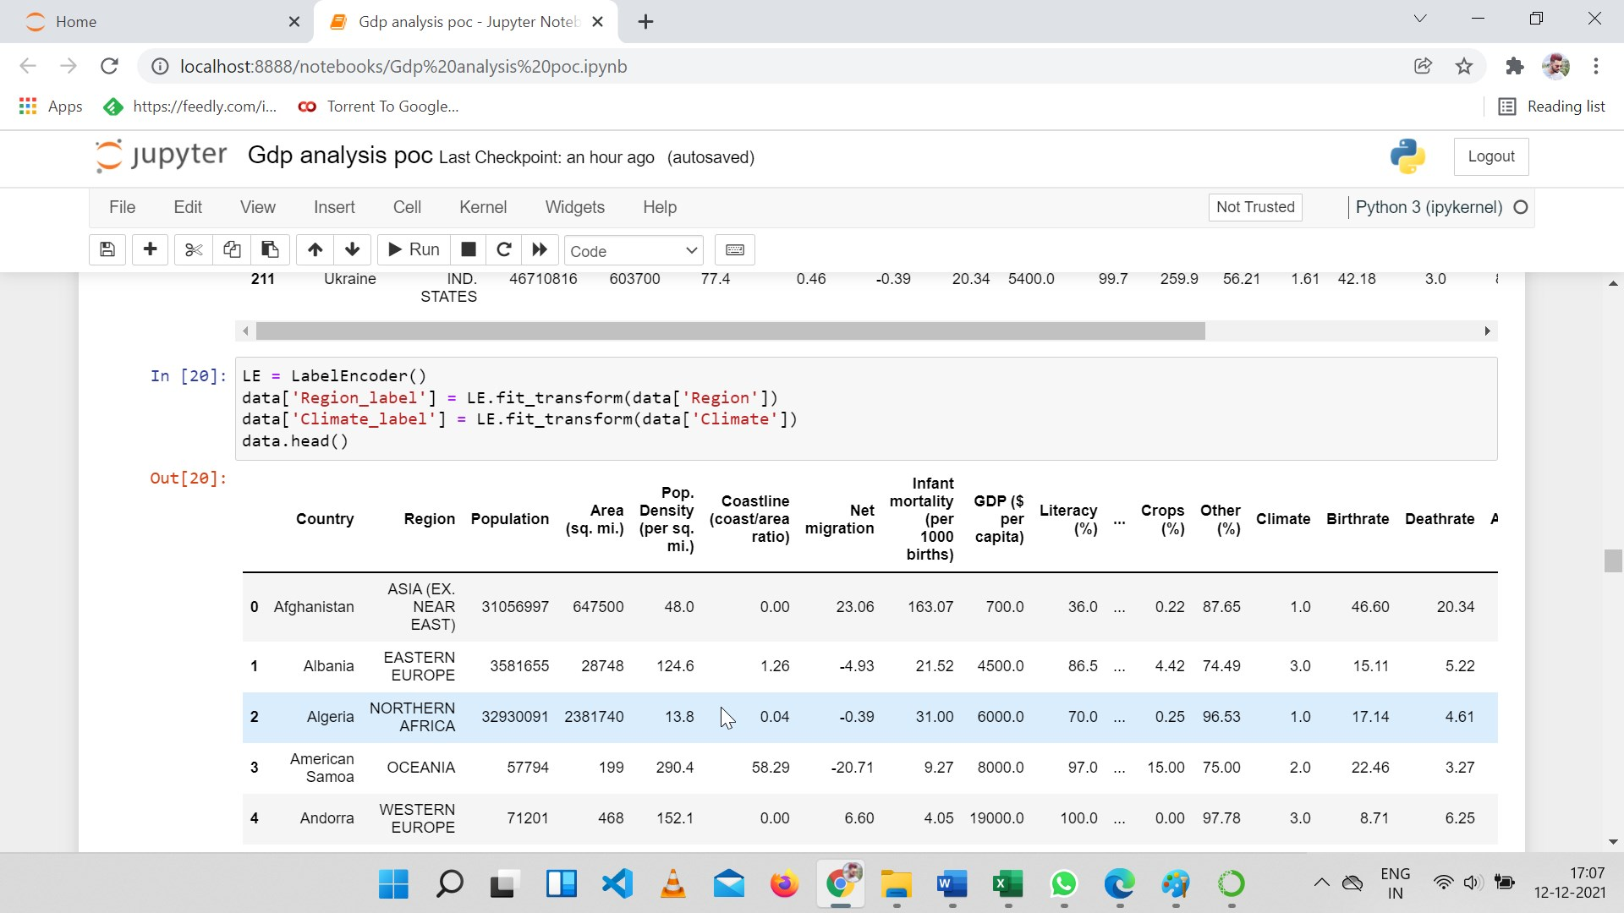

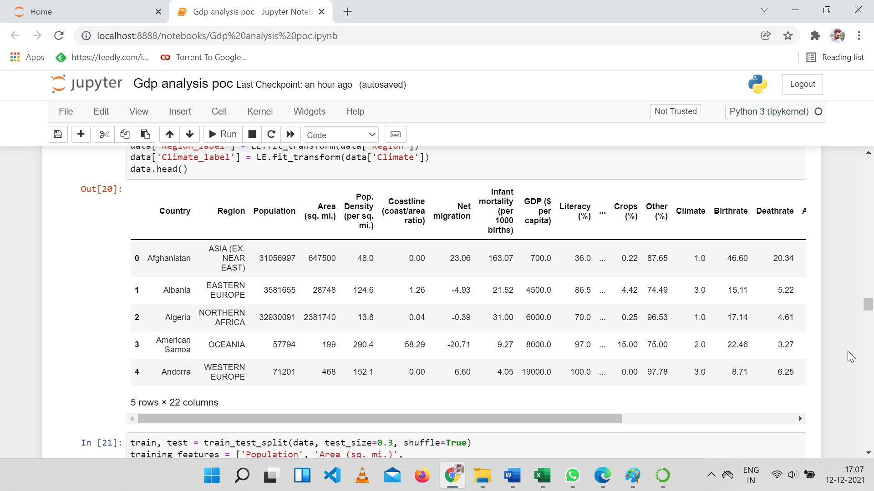

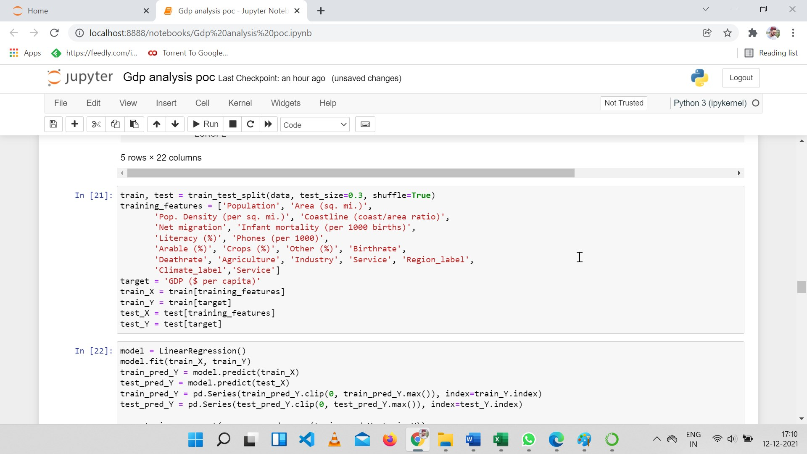

First let’s try the linear regression model. As for metric, I will check both root mean squared error and mean squared log error.

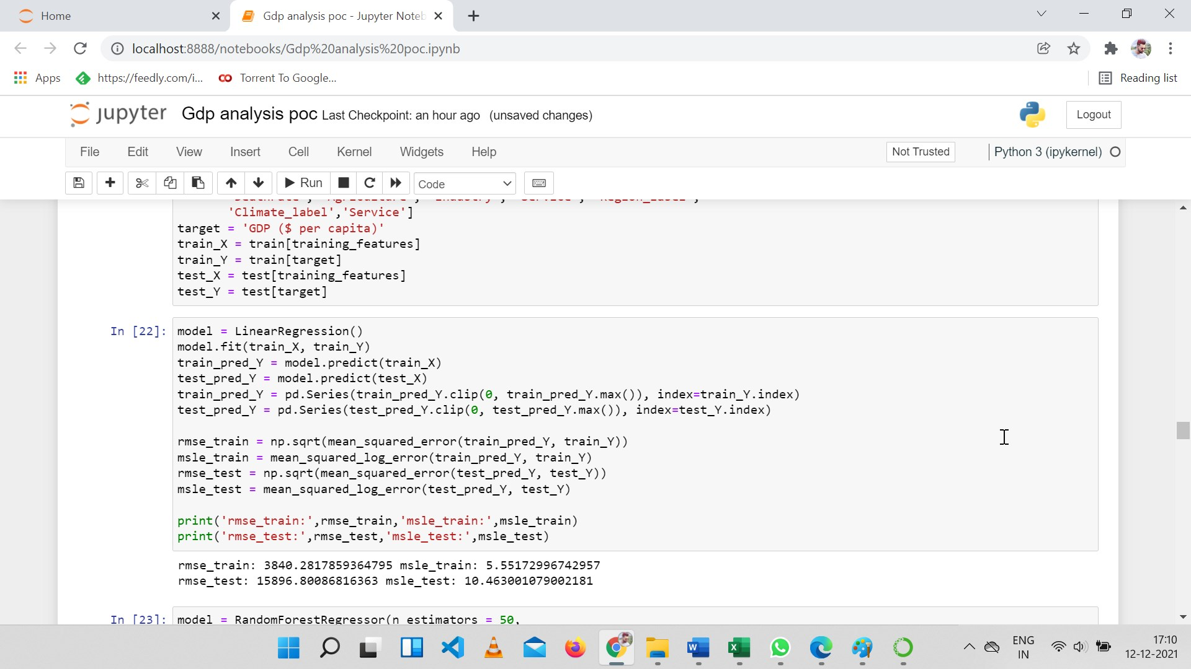

As we know the target is not linear with many features, it is worth trying some nonlinear models. For example, the random forest model

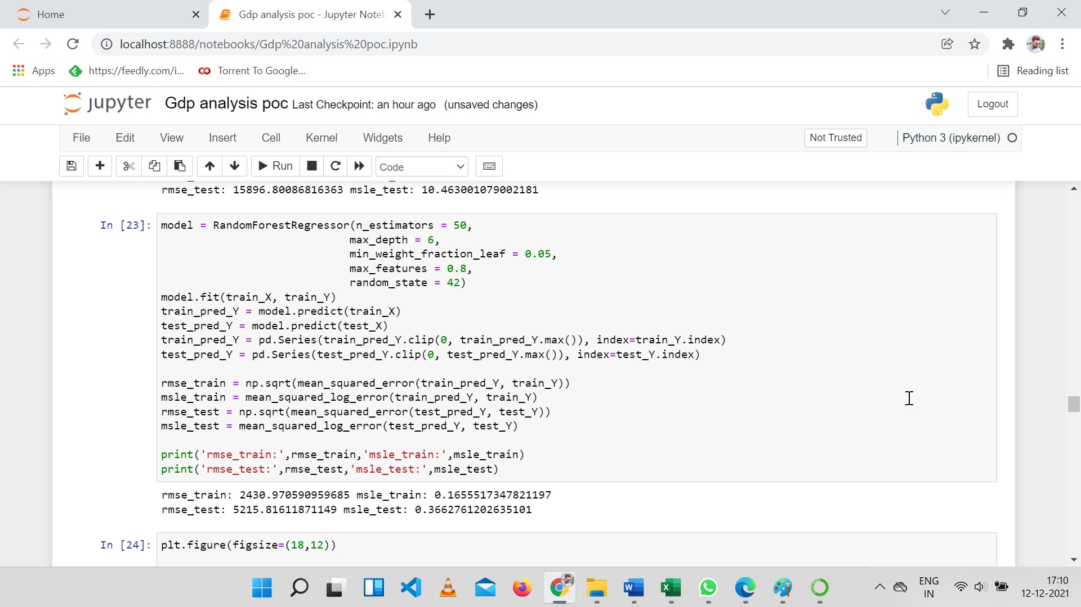

### **Visualization of Results**

To see how the model is doing, we can make scatter plot of prediction against ground truth. The model gives a reasonable prediction, as the data points are gathering around the line y=x.

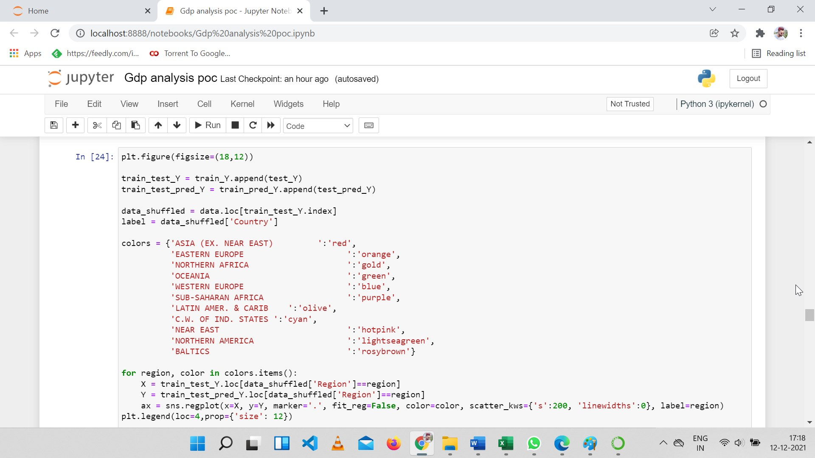

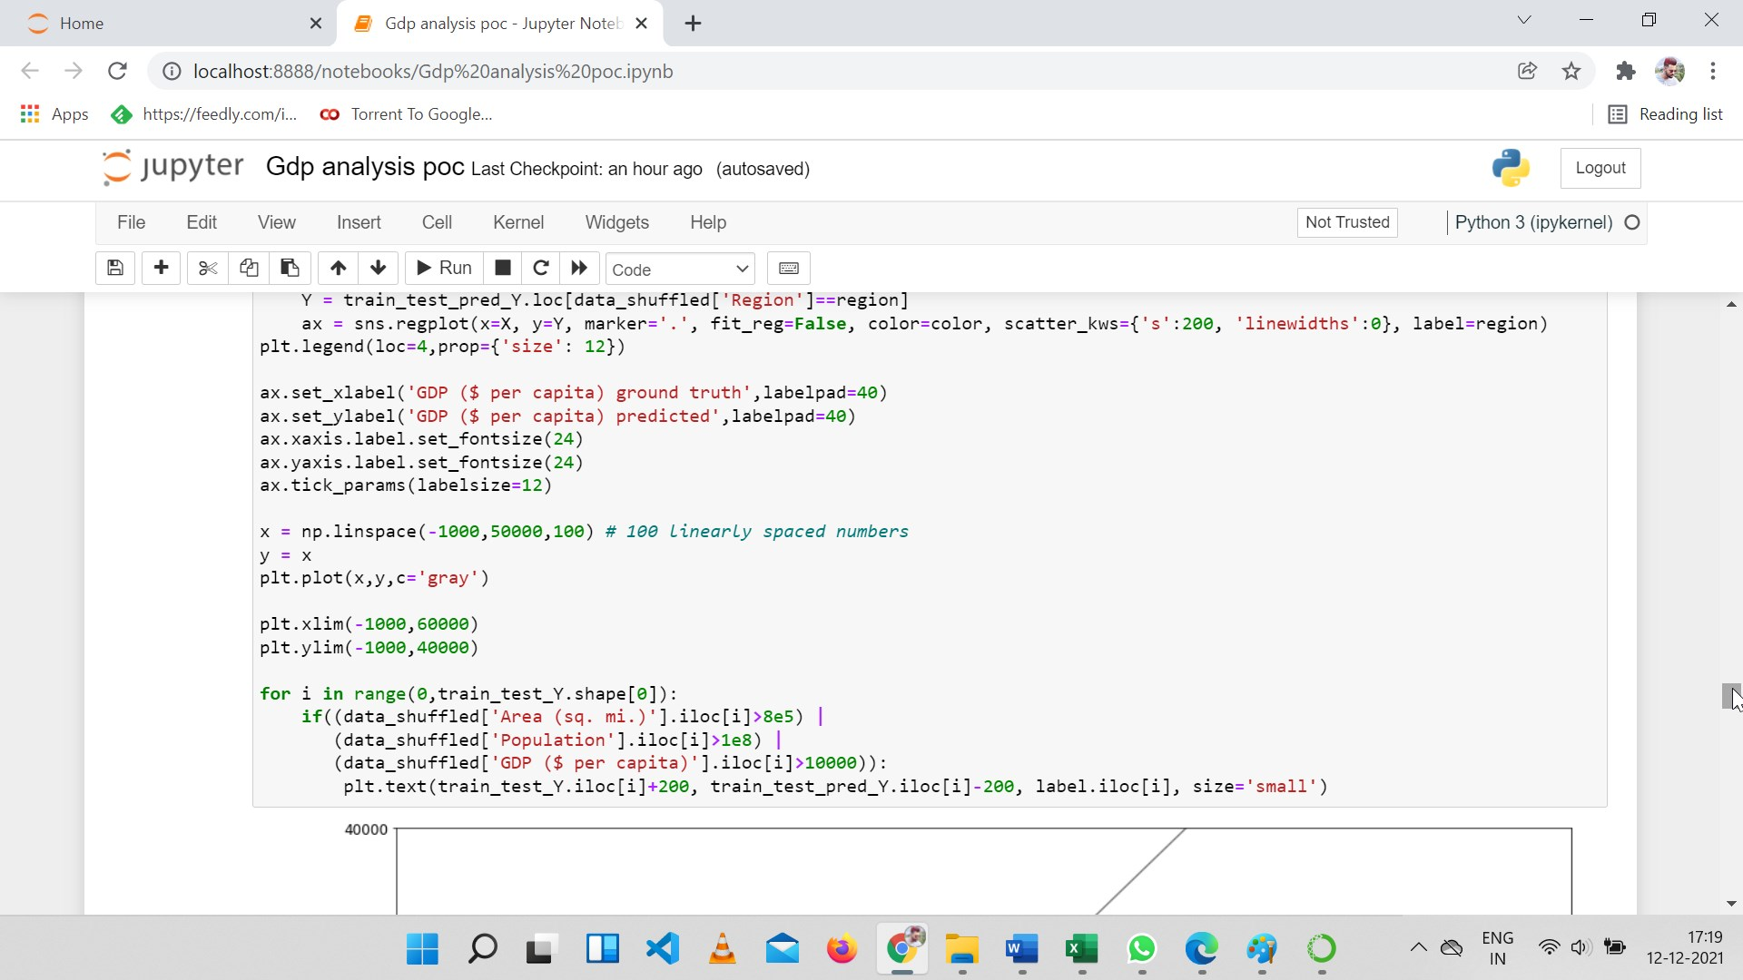

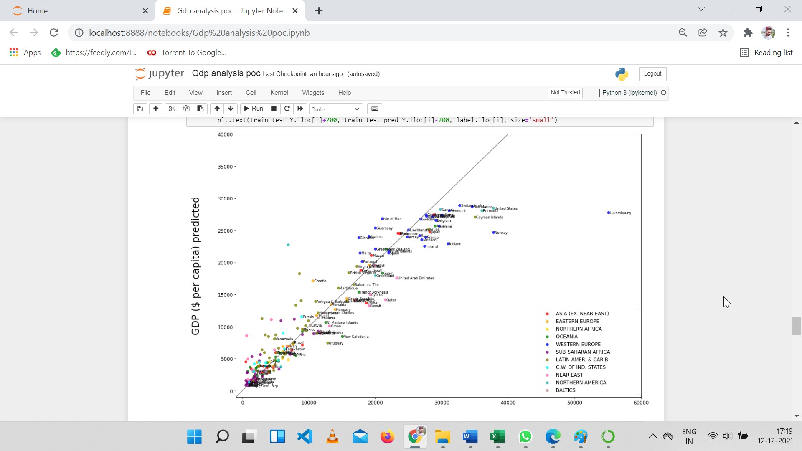

GDP PERCAPITA $ GROUND TRUTH

## Total GDP

### Top Countries

It is also interesting to look at the total GDPs, which I take as ‘GDP ($ per capita)’ × ‘Population’.

Here are the top 10 countries with highest total GDPs, their GDP make up to about 2/3 of the global GDP.

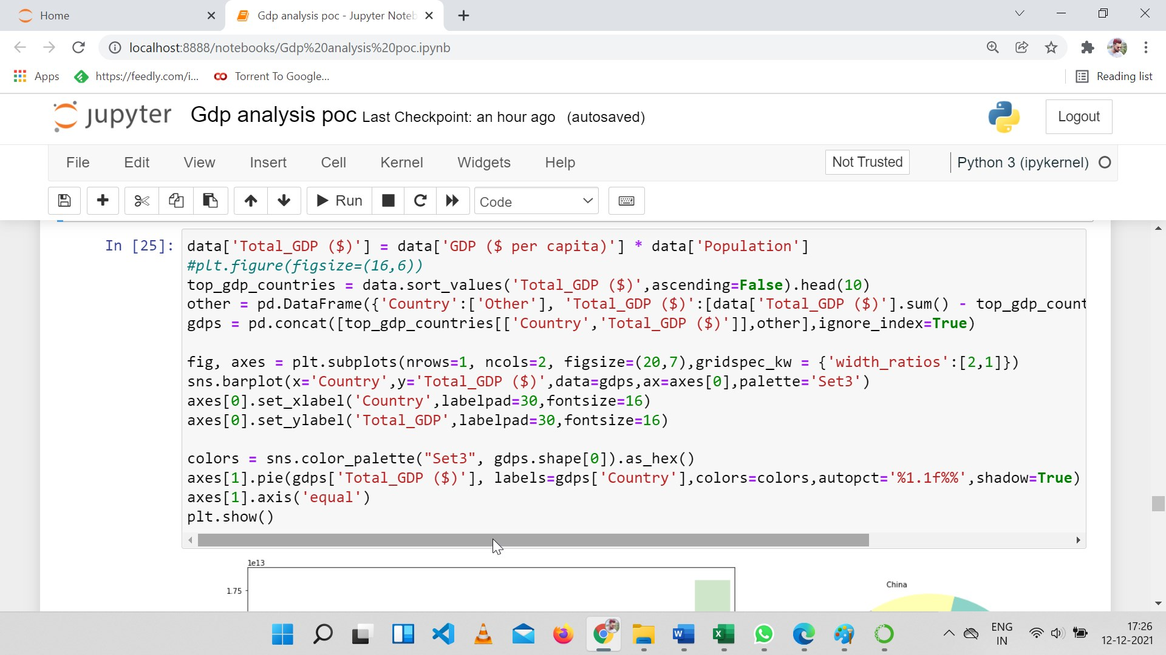

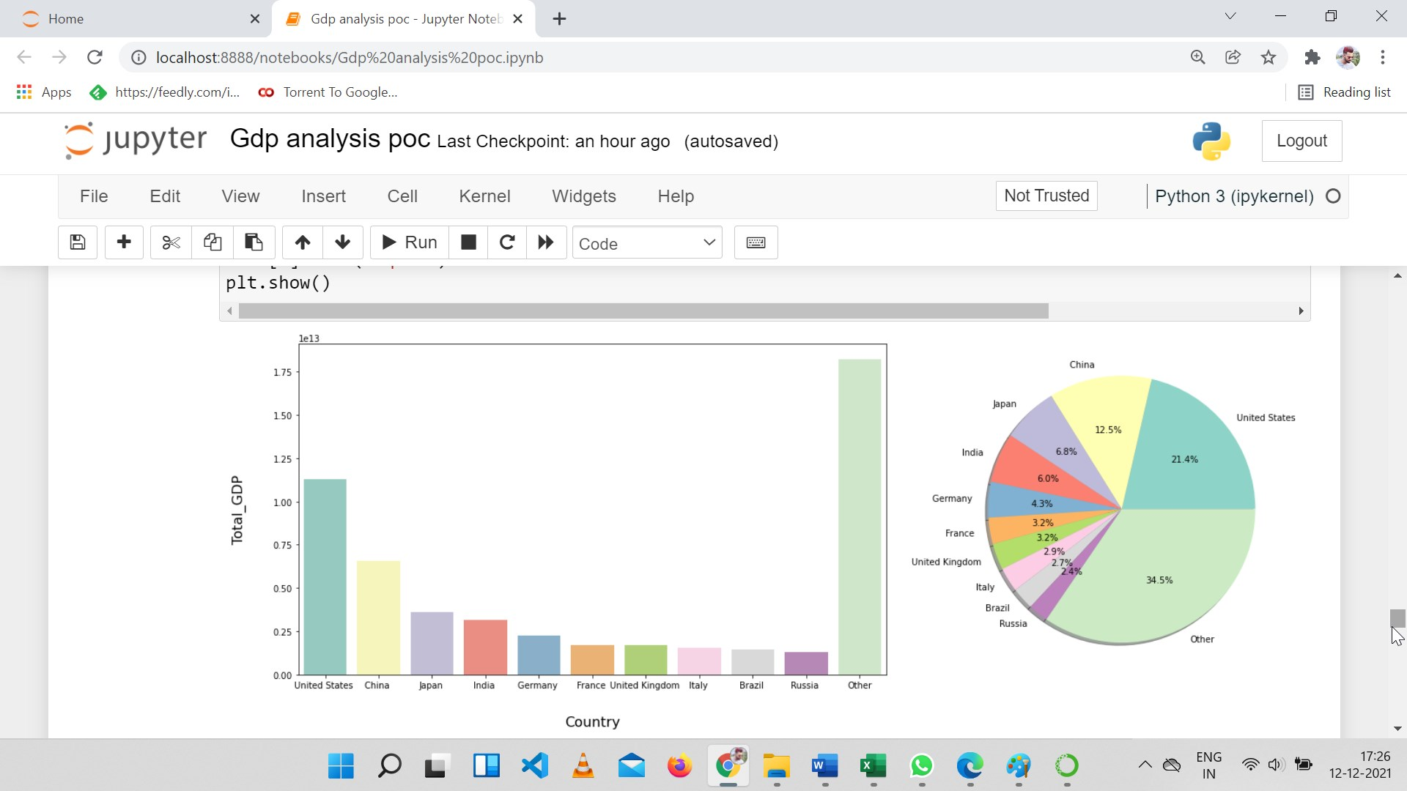

Let’s compare the above ten countries’ rank in total GDP and GDP per capita.

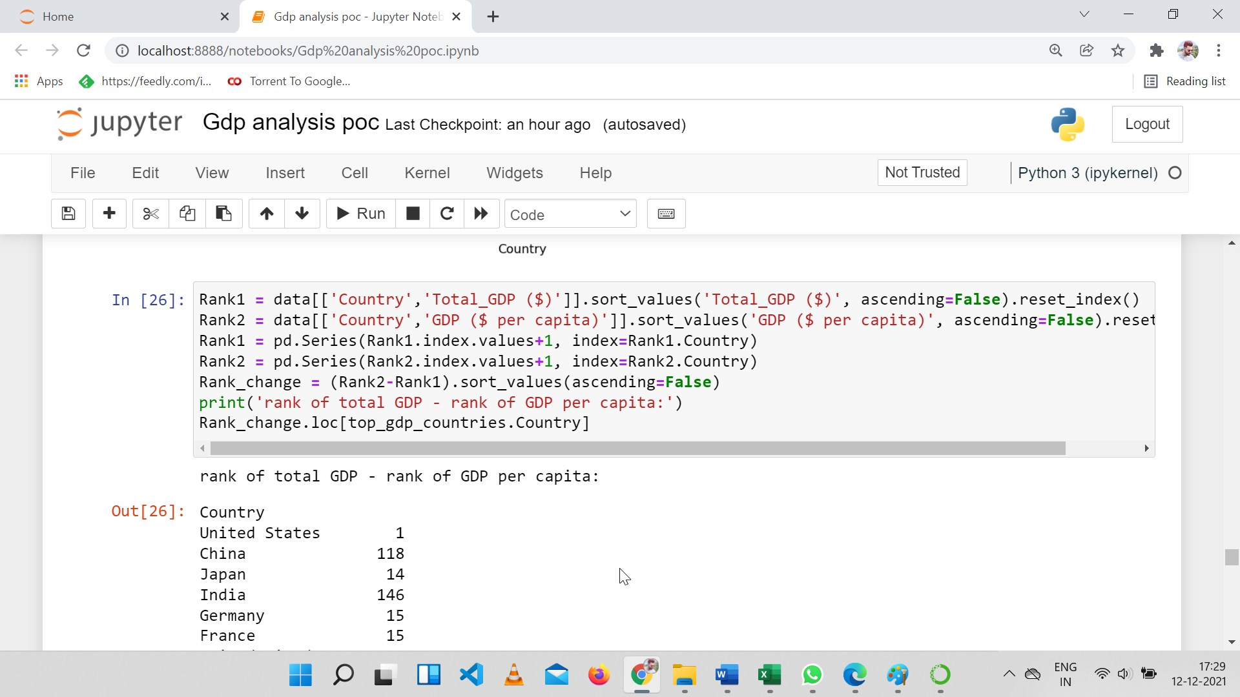

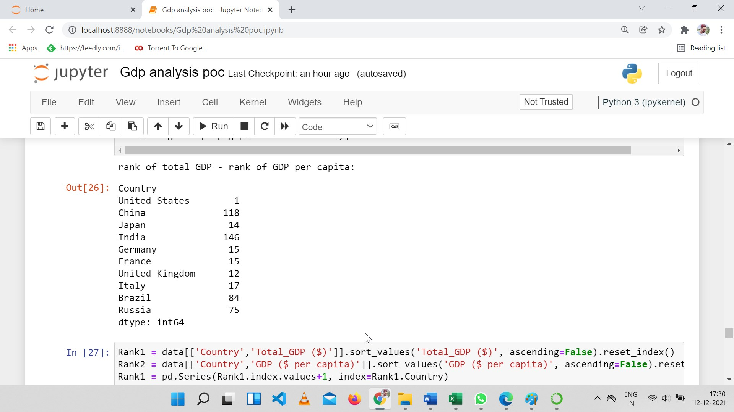

We see the countries with high total GDPs are quite different from those with high average GDPs.

China and India jump above a lot when it comes to the total GDP.

The only country that is with in top 10 (in fact top 2) for both total and average GDPs is the United States.

### **Factors affecting Total GDP**

We can also check the correlation between total GDP and the other columns. The top two factors are population and area, following many factors that have also been found mostly correlated to GDP per capita.

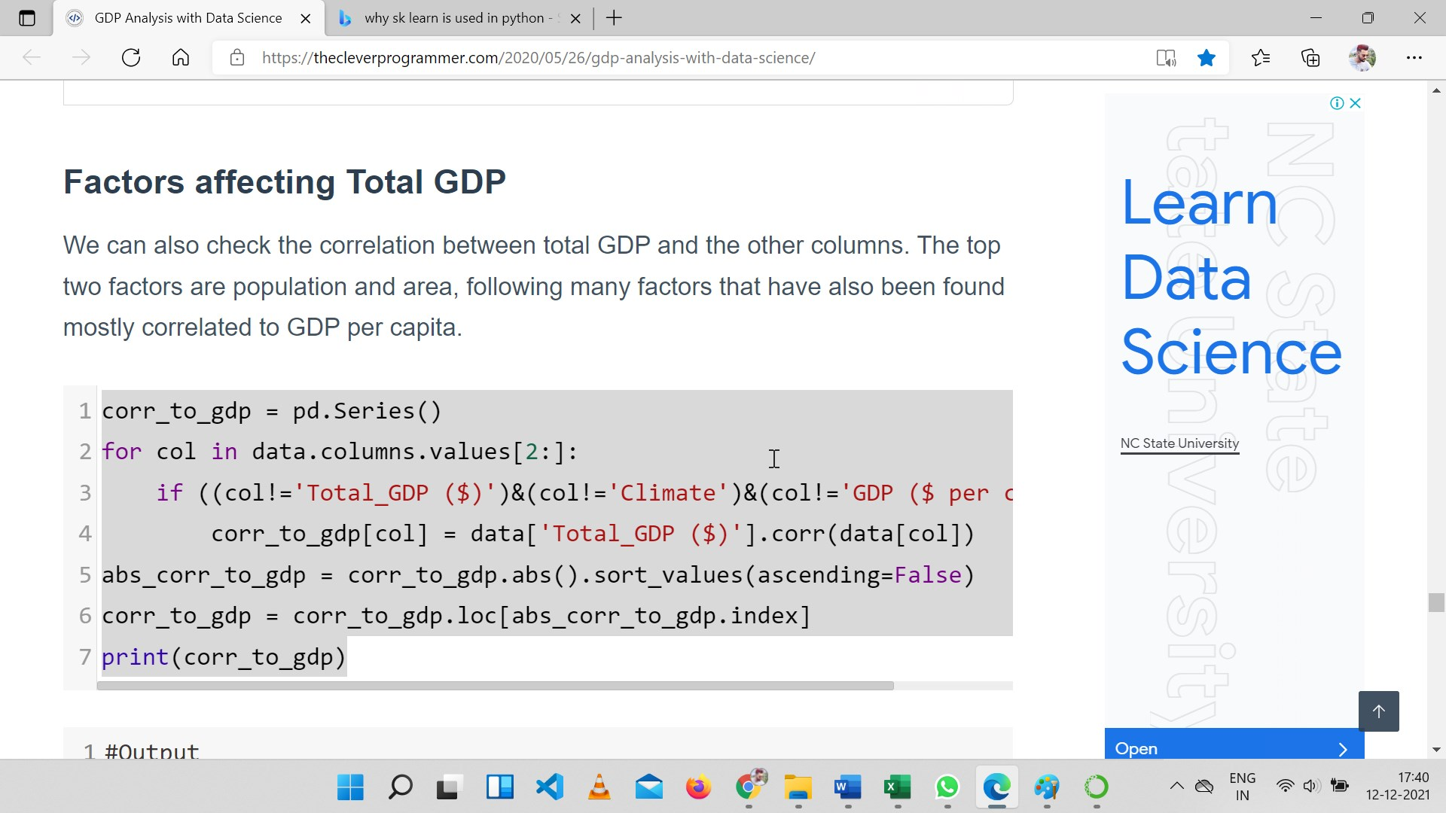

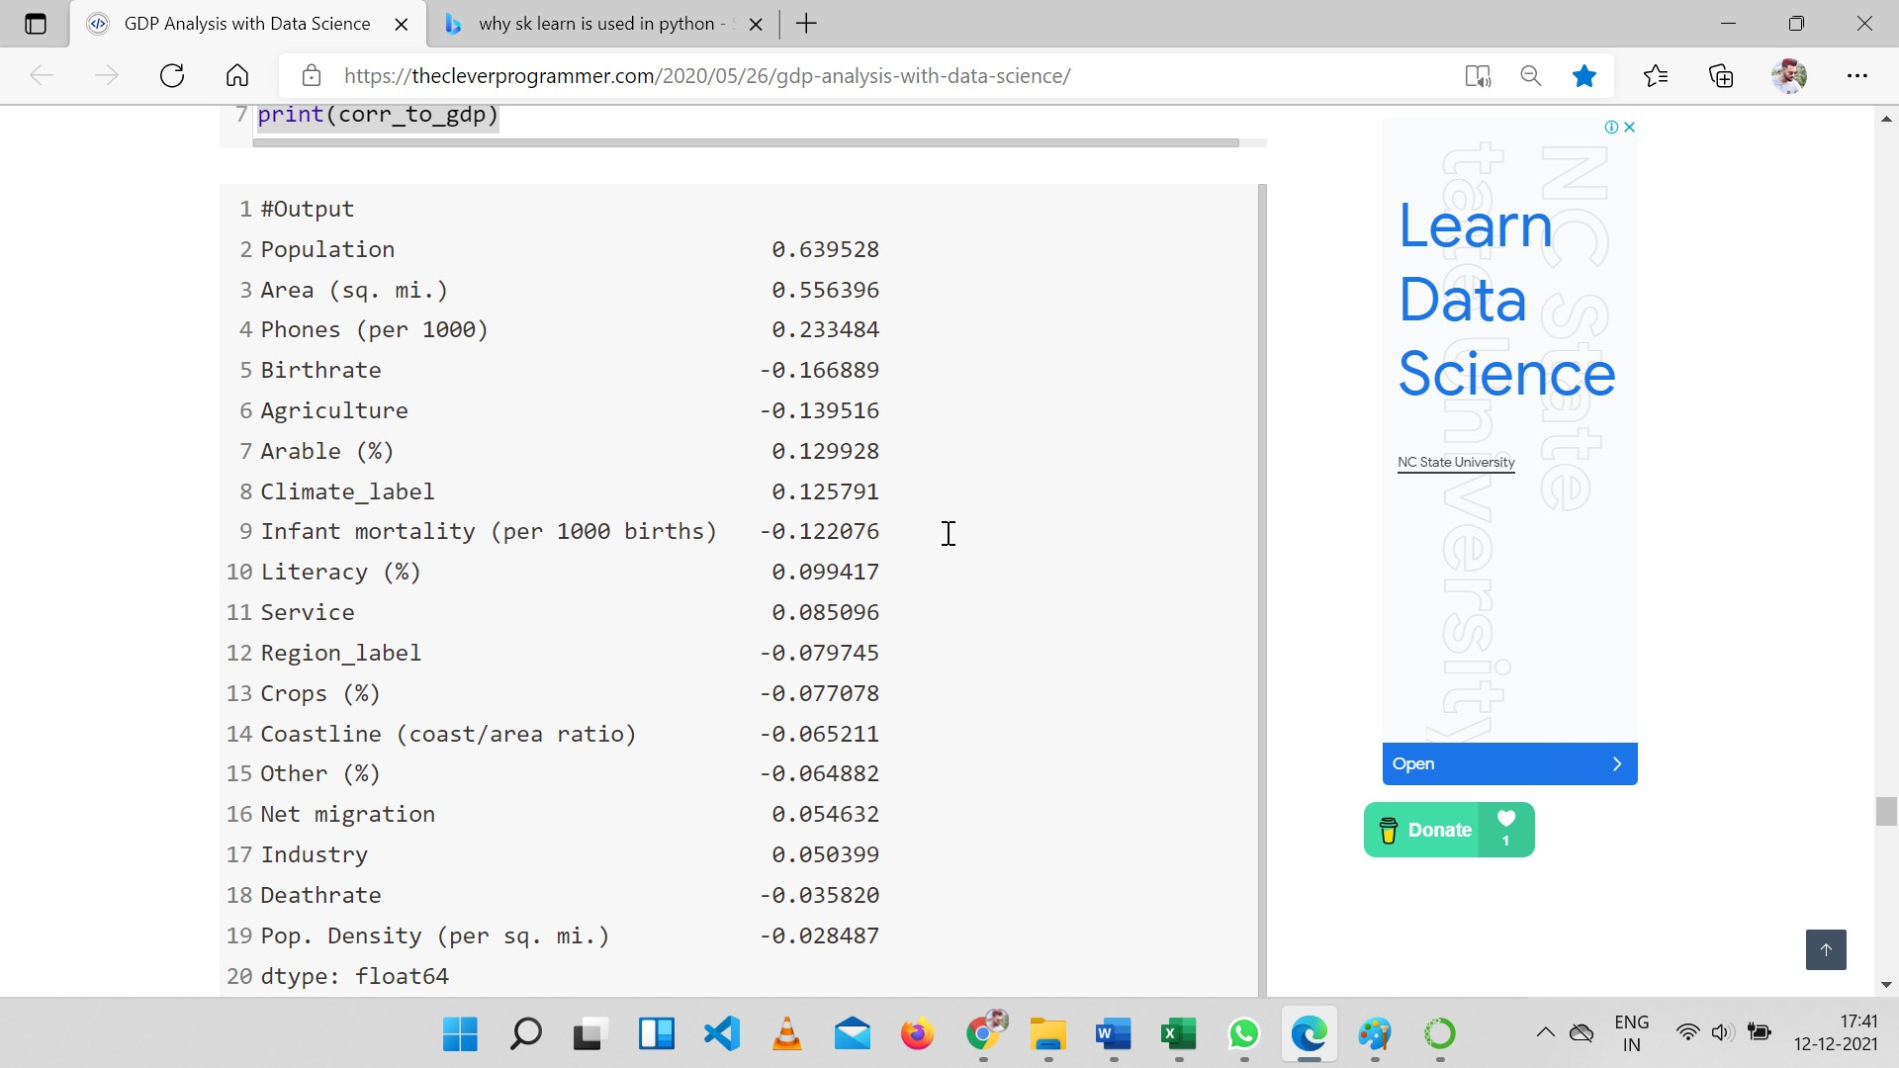

### **Comparison of the Top 10**

Finally, let us do a comparison of the economy structure for the ten countries with highest total GDP.

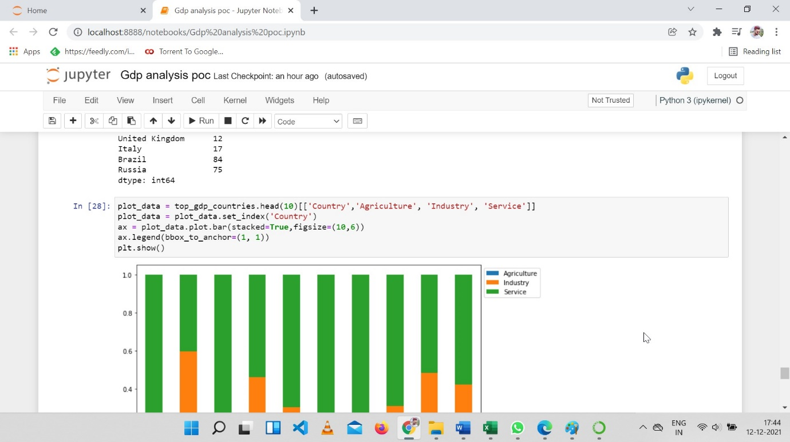

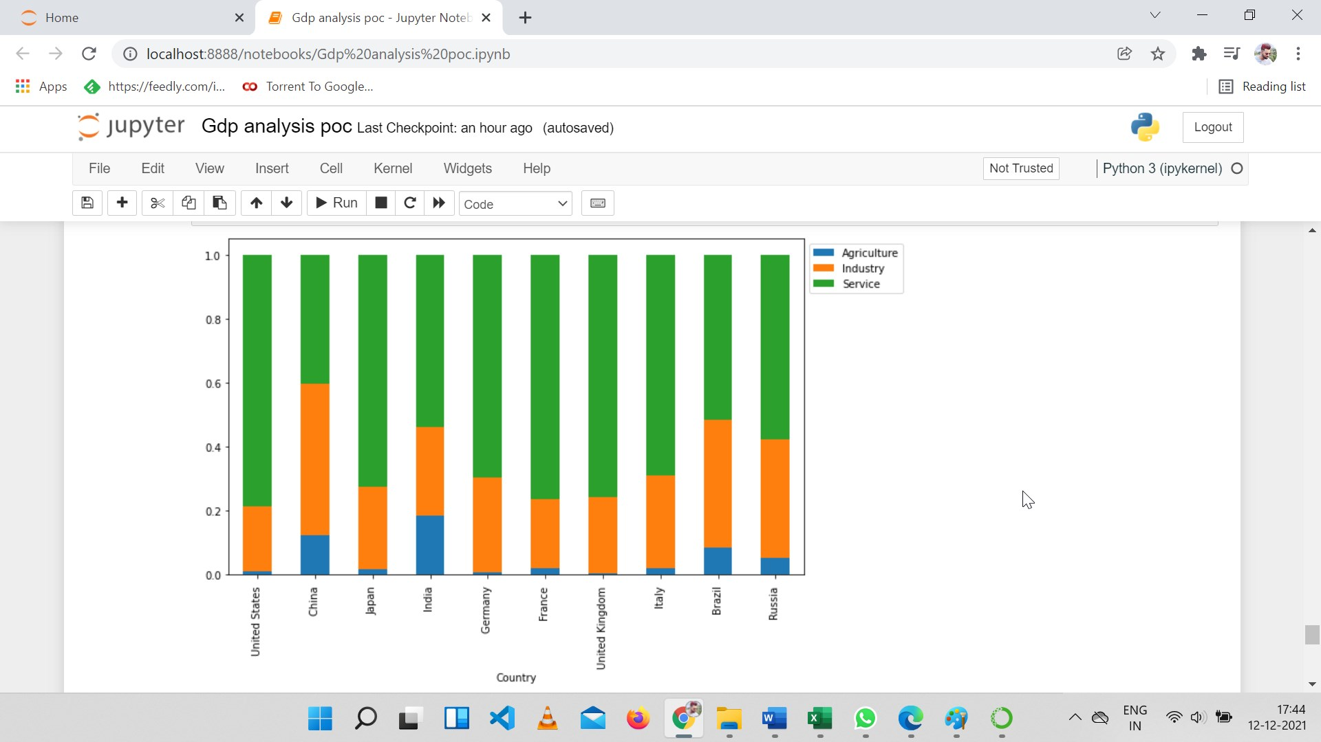

**As well as their land usage**

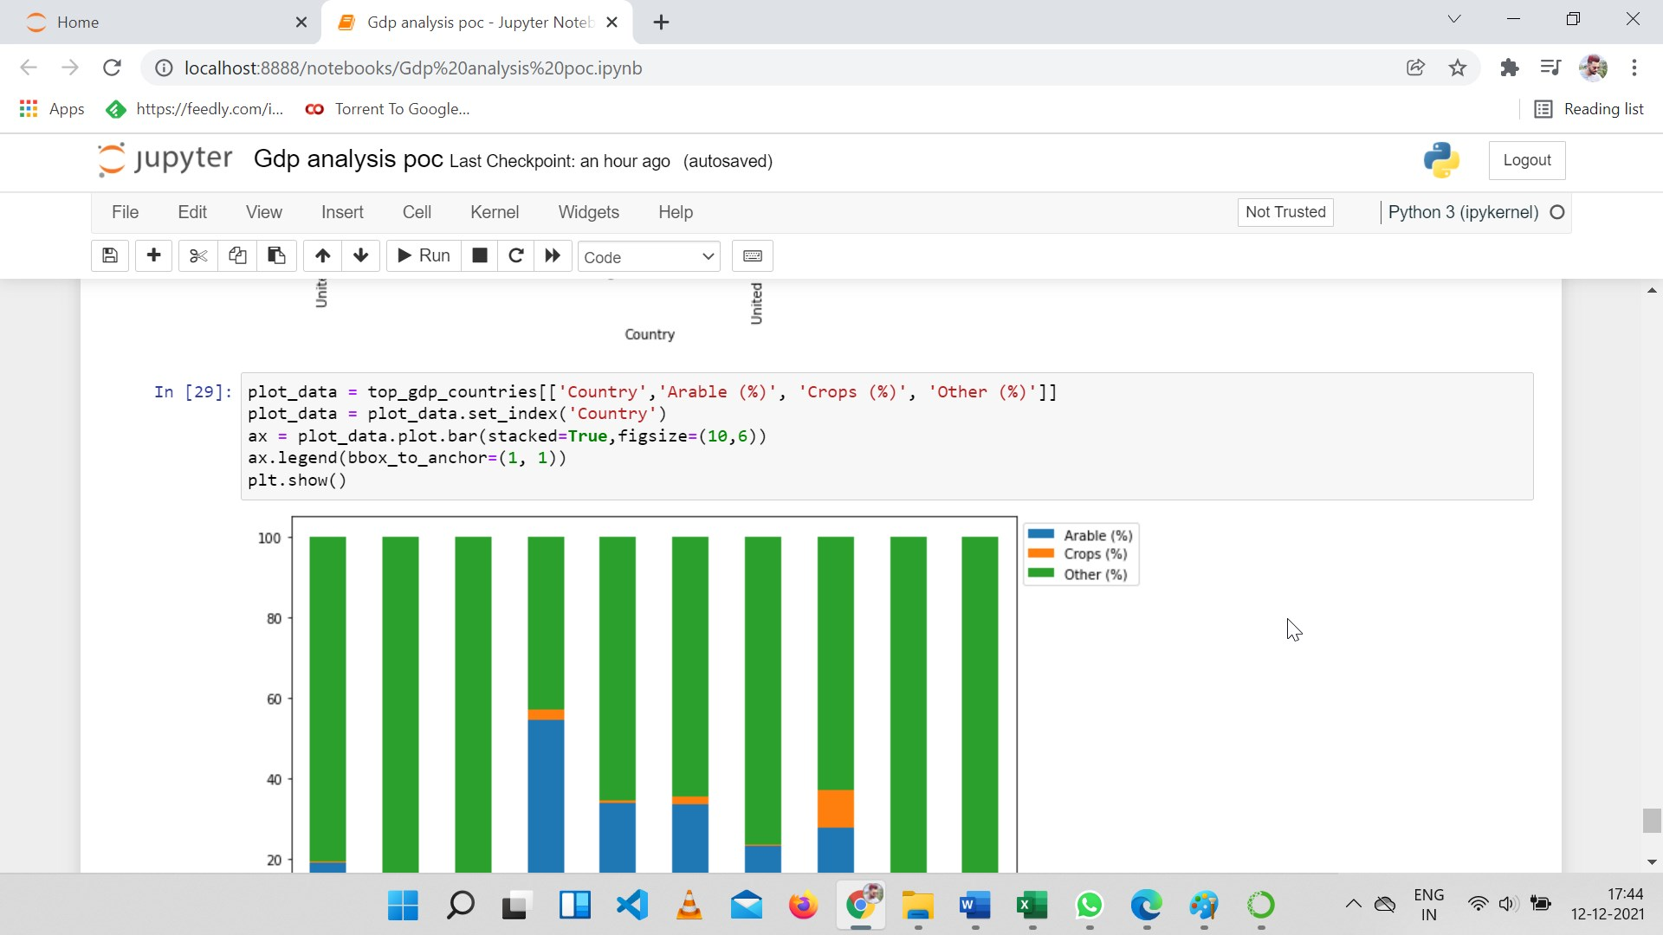

**Output**

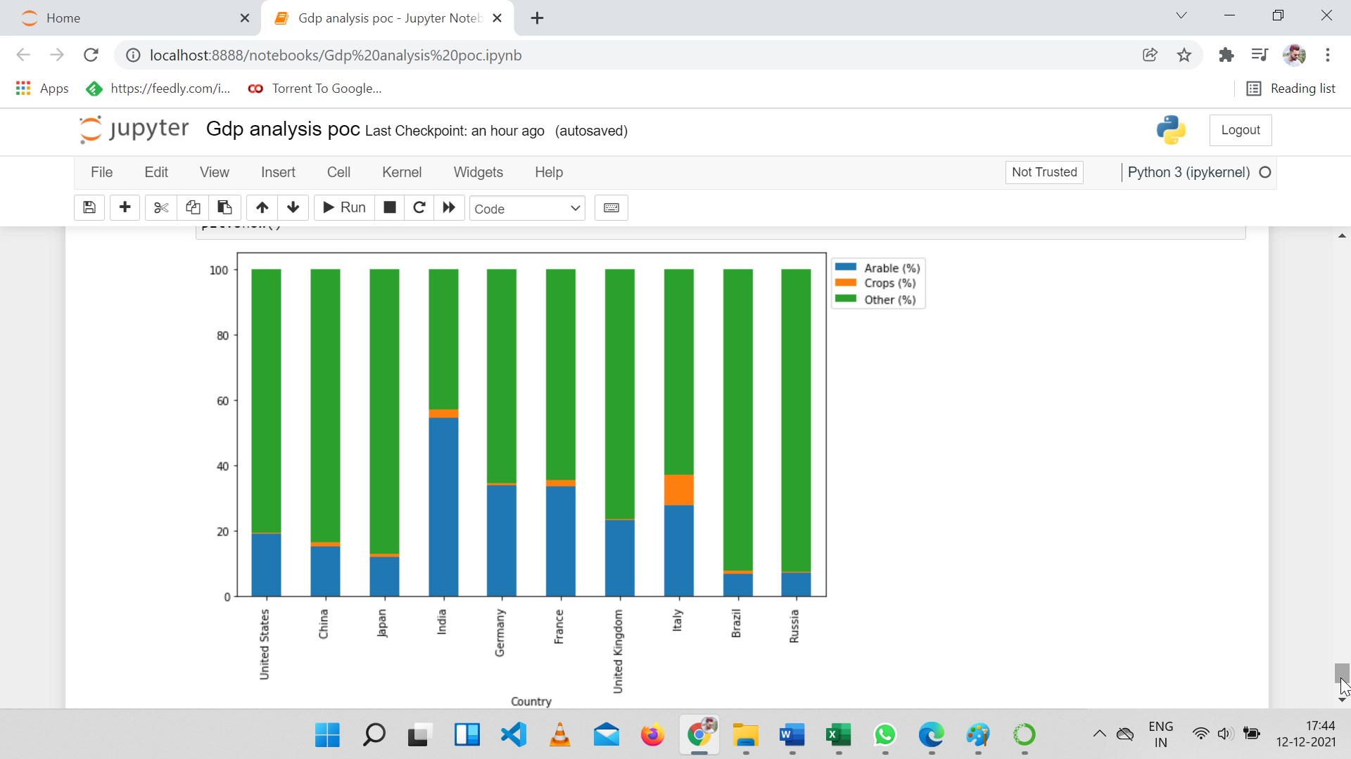

As we can see here India has more arable land percentage as compared to other countries and Italy has maximum crop percentage.

**4. Conclusion**

In this study we came to know that GDP per capita is an important indicator of economic performance and a useful unit to make cross-country comparisons of average living standards and economic wellbeing. However, GDP per capita is not a measure of personal income and using it for cross-country comparisons also has some known weaknesses. In particular, GDP per capita does not take into account income distribution in a country. In addition, cross-country comparisons based on the U.S. dollar can be distorted by exchange rate fluctuations and often don’t reflect the purchasing power in the countries being compared.

Regression analysis showed that of the twenty independent variables, population, GDP, Area, life expectancy and literacy are the five factors that affect GDP per capita the most. Economic discrepancies among the countries has been a subject to be explored.

On this note I would like to mark an end of my POC and I am also providing a GitHub link attached to this, where you can easily find my file.

Thank you